4 Ridiculous Myths About the Middle Ages Everyone Believes
Adapted from an article by Steve Kolenberg January 13, 2013
When you think of the Middle Ages, chances are you picture gallant knights sitting astride brilliant destriers galloping through a sea of plagues, ignorance, and filth. And you can hardly be blamed for that, when everything from the movies you watch to your high school history teacher (who was mainly the football coach) has told you that...

Myth #4. Scientific Progress Was Dead
They call it the Dark Ages for a reason. Any scientist who dared to actually study the universe would be shut down by the Catholic Church, which thought all that nonsense was immoral and that the Bible was all the learnin' anybody could possibly need. They even thought the Earth was flat, for crying out loud.
The Reality: Aside from the fact that most people in the Middle Ages did not think the Earth was flat, the church wasn't responsible for killing science -- to the contrary, it was largely responsible for saving it.
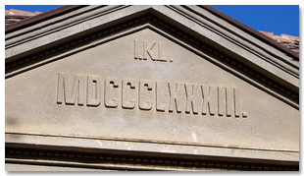
After the barbarians invaded Europe and Rome went the way of the dinosaurs, the Catholic church was the last remaining aspect of Roman culture in Western Europe. The church went about setting up monasteries across Europe, and along with the monks came the monks' massive libraries. Monks were just about the only educated people in the early Middle Ages, and pretty much everything we know about this entire time period was written by them.
As time went on, the church stepped it up a notch and started establishing universities to foster the preservation of knowledge. At these universities, students studied more than most college kids do today, with an average bachelor's degree taking up to seven years to earn, and a master's or doctorate taking several more. The universities were also big on translation, having successfully translated into Latin guys like Aristotle and Plato, which effectively made the Renaissance possible. Around the same time as universities were popping up all over Europe, the Crusades were bringing Europeans into contact with advanced Muslim ideas of science and technology. Ideas like the compass and the astrolabe came to the West via Muslim Spain and came in handy during the later Age of Exploration. Italian merchants came back from trading in North Africa and gave us another innovation: Arabic numerals.
Yeah, right, like people are going to want to learn a whole other set of characters.
Medicine also made massive advances thanks to the university system. Contrary to popular belief, dissection of corpses was actually fine and dandy with the church, and medieval universities often did it in the basement (OK, so maybe it wasn't totally fine and dandy). By the 14th century, there were functional hospitals, and doctors had learned how to use antiseptic when lopping off people's body parts.
And that's a good thing, because everybody was encrusted in filth back then, right? Well, about that ...

Myth #3. Everyone Smelled Like Complete Poop
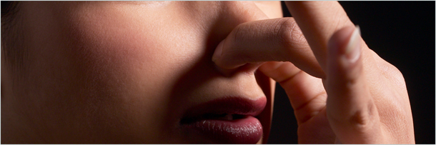Getty
Even if we know nothing else about the Middle Ages, we know that everyone was absolutely filthy. Medieval peasants looked like something straight out of Monty Python and the Holy Grail ... and the upper classes were hardly any cleaner. People back then took baths with about the same frequency as we go to the dentist -- a couple of times a year for the obsessive ones.
The Reality: They were way into bathing for much of the Middle Ages. Maybe too into it -- they continued the Roman practice where a bunch of strangers got naked together for communal bathing, and most towns and even villages in medieval Germany had a communal bath where craftsmen would hang out and bathe together after a hard day's work.
Meanwhile, not only was it common for medieval folk to wash their hands before and after eating, it was also customary to offer to bathe with guests when they entered your home, something The Man has repeatedly reminded us is no longer acceptable in modern society. Medieval demand for soap (usually made from animal fats, with a variety of oils and salts added) was so great that by the 13th century, soap was being made on an almost industrial scale in Britain, Italy, Spain, and France.
So why do we picture everyone as wallowing in their own filth back then? Well, things changed all at once. If only an act of God could change Europe's epic bathing culture, they got one -- in the mid-14th century, the Black Death strolled up and kicked Europe right in the teeth with its pestilence boot. Suddenly, smart people were telling the previously washed masses that bathing was a surefire way to open your body's pores and invite in all the bad spirits or gremlins or whatever (they weren't too savvy on what caused illness back then).
As a result, by the early modern period of history, bathing had become obsolete. So it's entirely possible that George Washington rated higher than Richard the Lionheart on the smell-like-poop-o-meter.

Myth #2. Knights Were Honorable, Chivalrous Warriors
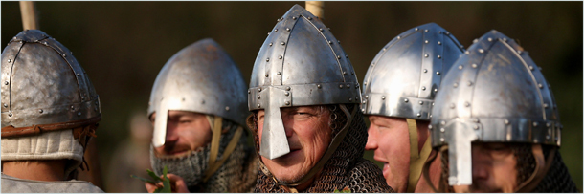Getty
Knights were gallant and brave warriors, charging into battle to slay the dragon and rescue the fair maiden.
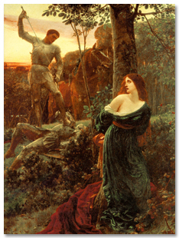
The Reality: Knights often had less in common with this: And more in common with this:
Remember, knights were professional warriors, and when there wasn't a war to fight, they had to find something to do with their training for war. Most of these guys were relatively young and didn't have Call of Duty to satisfy their violent urges, so they tended to take it out on the local population. Toward the 11th century, many of the local lords started bickering over who would get a slice of the Holy Roman pie that Charlemagne baked, and the knights were at the forefront of these petty wars. These "wars" were less Braveheart-style epic battles and more knights rolling up into villages and slaughtering everybody.
The church tried to curb these conflicts, because frankly, they were nasty and threatened the stability of everything. First they tried to gather up all the knights and shake various body parts of dead saints at them, but when that didn't work, the Pope called the First Crusade and exported all these jerks to the Middle East, where they chivalrously ate babies and massacred the entire population of Jerusalem.
Later attempts were made to get these young 'uns under control, one being the chivalric code that was adopted around the 13th century. Examples like Sir Lancelot and Edward the Black Prince were raised to show knights how to behave in battle and in peace. Knights were encouraged to "defend the weak," but "the weak" was commonly interpreted as noble women and children, not peasants. So noble-on-noble violence may have decreased, but it was still totally cool for knights to kill and rape peasants, since, you know, they didn't really count.

Myth #1. Life Was Horrible and Everyone Died Young
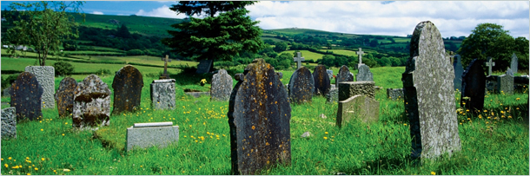Getty
Life in the Middle Ages has famously been described as "nasty, brutish, and short." The food stunk, the housing stunk, the work stunk, everything stunk. Luckily, people didn't have to endure all the perpetual stink for long, since they only lived to see 35, tops. Today, if you see a character older than 60 in a movie set in the Middle Ages, he's also a wizard.
The Reality: As for lives being short, while it may be true that the average life expectancy was 35 years, we tend to overlook one very important word there: average. Infant mortality was brutal, since vaccinations against childhood diseases didn't exist yet and medicine was still in its "Here, chew on this root and stick some leeches on your skin" stage. So that skews the average way down. But if a male living in 1500 managed to see his 21st birthday, he was expected to live around 50 more years from that point.
The typical perception of the medieval peasant is someone breaking his back doing nonstop labor for lords who wanted the poor guy to work til he died, but your typical peasant actually worked around eight hours a day, with long breaks for meals and naps. And did you know that peasants got more time off than you do? Sunday was an automatic day off, and when you factor in long vacations at Christmas, Easter, and midsummer, plus all the saints' days (considering the fact that the Catholic church has even more saints than it does scandals), and medieval peasants were on holiday for a good one-third of the year, it’s not so bad.

