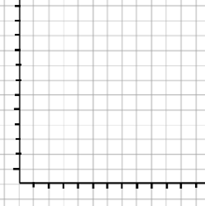
Exercise: Please make a bar graph or chart, like this:

- Label the Y-graph in units of 1 million.

- Label the X-graph in units of 50 years, starting with the year 1000.

- Identify these two points on the graph:

  - In 1066, the population of England was 1.1 million.
  - In 1347, the population of England was 3.7 million.
  - Then draw a line between those two years.

- Next calculate England’s population by 1400 by drawing a point. You will need to guess.

Now, the truth:

