THE CRUSADES
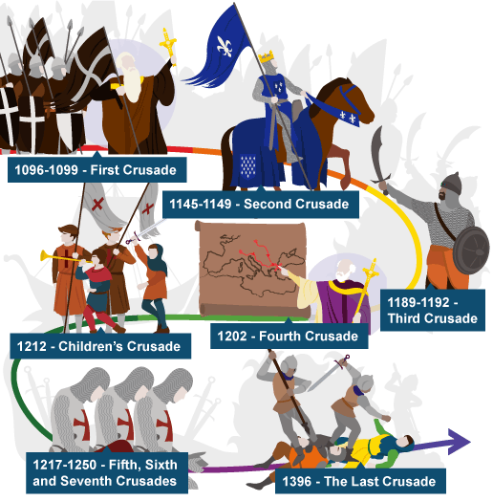

CRUSADE
Start: 1095 Letter Constantinople
1096 Pope Urban II speech
1096 Peasants’ C.
1099 1st C. conquer Jerusalem
1147 2nd C. fails
1189 3rd C. (Richard the L-H)
1204 4th C. (Christians conquer Constantinople)
1212 Children’s C.
1216-1270 5th-8th C.
1291 Last Christian city falls

