Welcome to the world of the Medieval--what many have called the Middle Ages.
Here at Moore Square we call it

The time period we will immerse ourselves in over these next nine weeks runs a thousand years long. It begins with the gasping death throes of the Roman Empire’s collapse, and comes to a gradual end as Europe becomes stronger during what we call the Renaissance.
Let’s get some misconceptions cleared up right away, shall we?
Reality Check #1: These are not simply the “Dark Ages.” Sometimes people call these times that because it makes our own age sound amazing in contrast. The reality? These were times of invasion, incurable disease, pain and misery, ignorance, horrific violence, and hatred, but we will also learn of examples of ways to protect one’s community against scary barbarians, castles, new inventions, medieval fun and improvements in society, enlightened rulers and church leaders, reformers, and calls for peace.
Reality Check #2: We are not just learning about Knights. Yes, of course, huge guys who trained since the age of seven for combat, who wore full plate armor and wielded heavy lances, two-handed swords, and twenty-pound Danish axes ARE really fascinating, I agree. But there were hard-working peasants and literate monks, ambitious kings and queens, talented merchants, universities, torture chambers, crusaders, physicians, court jesters, and guilds. We’re learning about all of them, and more.
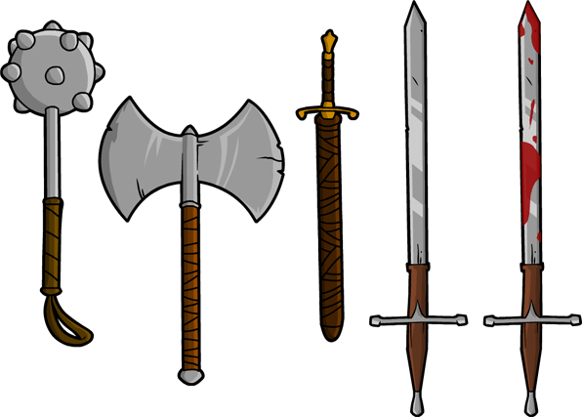
Reality Check #3: There are so many myths about the Middle Ages. No, people did not smell that bad because they did commonly take baths. No, people did not generally think the world was flat back then. No, people did not usually believe in dragons or giants, though many likely believed in witches and demons. Yes, in many towns, very few people could read and write. Yes, medieval people would commonly die as babies, as kids, or as young adults, far more than we do now in America.
When are we going to learn about what?
Remember when you learned about the Middle Ages in sixth grade? We are diving in deep into subjects you didn’t have any time to learn of back then. Here’s what it looks like:
Week 1: The Middle Ages Begin! (Overview, Rome Falls, the Huns, and Charlemagne)
Week 2: When Barbarians Attack! (The Vikings, Islam Expands, and Byzantium)
Week 3: Castles! (Why and how to build one, Siege machines, Feudalism, Manors, and Guilds)
Week 4: Knights! (Battle of Hastings, Weapons and armor, Jousts, Heraldry, Chivalry)
Week 5: The Church! (Monasteries, Pilgrimages, Popes, Traditions, Universities, Gregorian Reform, Investiture Controversy, “Great Schism,” and start of the Crusades)
Week 6: Bloodshed! (Crusades, Mongols, the Hundred Years’ War, Joan of Arc)
Week 7: Black Death! (Bubonic Plague, Wat Tyler’s Rebellion, William of Norwich, Strasbourg)
Week 8: Something Nice, at last! (Architecture, Courtly Love, Literature, Art, Culture)
Week 9: Knightfall! (The End of Knights, Inventions and Merchants, Constantinople, 1492)
What else will we do?
You will have a quiz every Friday, assessing how much you have learned that week. We will also be responsible for one Biography on an important figure who lived during the Middle Ages.
In addition to these units, there will be a performance toward the end of this class. By the third week of this class, you will be assigned a role within your castle, and you will create an artifact from that time period that your character would have. Each student will belong to a different guild or social class that will be represented during the seventh week of class.
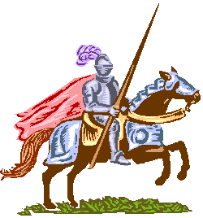
Make no mistake, you will have fun, but you will learn a lot. We’re talking about 1,000 years here, and there is too much to cover in class alone. There will be rigorous classwork day. By the end of this course, you will be able to know what a knight does, what he wears, what he believes, and why he fights. You will be able to recognize the most powerful nations on a map of Europe. You will understand the best way to defend, or capture a castle, and which weapons you’d use to capture or kill an enemy knight. You’ll be able to explain how the Black Death changed Europe forever, and how the Crusades were different than any other conflict ever.
It’s important!
Remember these people we study were not just characters in a movie. These were real humans who lived and breathed, and lived lives as unique as yours or mine. Someday people will study us like we are looking at those who lived a thousand years ago before us.
Returning these signatures (parent and student) is your first assignment. You may find a copy of this under Mr. Anderson’s website at msss7.weebly.com, as well as the Lesson plans.
Ad bonum anno,
_________________________ ________________________ _______________________
Parent Signature Date Student Signature Date Teacher Signature Date

