L. Sprague De Camp’s
Divide and Rule

The Time Period:
In the 1930s, many people were worried at what was going on in the USSR, formerly Russia. They were concerned that Communism, the government in that country, would spread and take over in other countries, especially in America. This was called “the Red Scare.” (The Communist flag was a red one with a yellow hammer and sickle on it.) How did this affect Science Fiction stories? Historian Michael Drout writes:

The theme of occupation—either by aliens or by foreigners with extreme technological prowess—is in fact a major theme in the SF of the 1930s. L. Sprague de Camp’s novella “Divide and Rule” is perhaps the most perfect example of this sort of story. Extraterrestrial “Hoppers” have set up a feudal system on Earth, but they are challenged by an underground revolution that uses as its supporting texts the works (banned by the Hoppers) of America’s founding fathers. Eventually, the revolution is able to succeed and free the world of the Hoppers. This plot is very similar to that of the earlier Buck Rogers (1926) and to Robert A. Heinlein’s later Sixth Column (1949), which, to be fair, was pushed by John W. Campbell and which Heinlein later claimed to be embarrassed by.

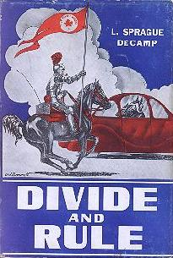
Summary:
A future earth has been conquered by the extraterrestrial "Hoppers," aliens resembling kangaroos. To secure their dominance, the Hoppers have reserved all advanced technology for their own use and resurrected the feudal society of the European Middle Ages, which they have imposed on the earthlings to prevent them from uniting against their conquerors. The story follows one such feudal lord, Sir Howard Van Slyck, a younger son of the Duke of Poughkeepsie, whose knight-errant quest leads him by degrees to question and challenge Hopper rule. After his brother Frank is executed for engaging in scientific research he joins the Wyoming knight Lyman Haas in the anti-Hopper underground, in which he becomes privy to a conspiracy to topple the alien rulers.

The Author:
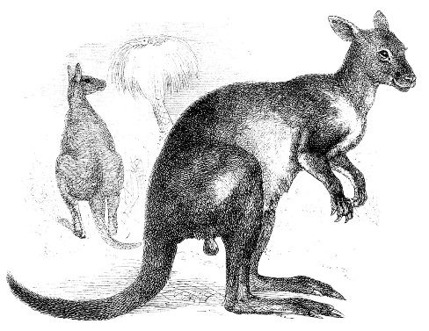
L. Sprague de Camp also wrote better-known stories, such as Conan the Barbarian books. They usually features strong warriors in ancient times who rescued scantily-clad females and saved the day by killing their enemies.

Draw your own animal invader on the back side.

