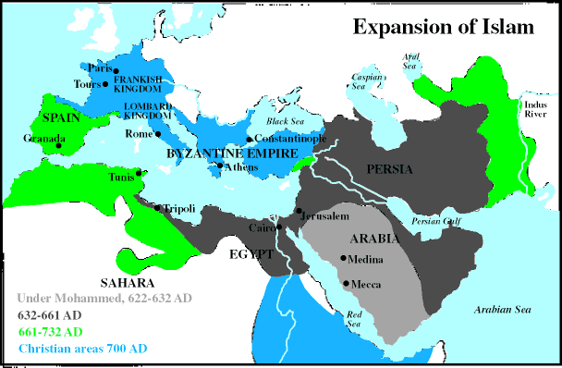

Sample Questions from the “Rise of Islam:”
Why would the Europeans be tired by the time Islam rises?
How many years ago did Mohammad flee from Mecca?
Why was Mohammad’s new religious teachings so fascinating and unusual for the people of Mecca and Medina?

