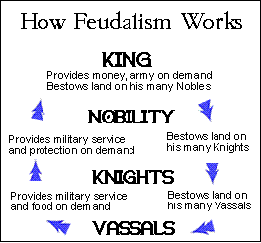
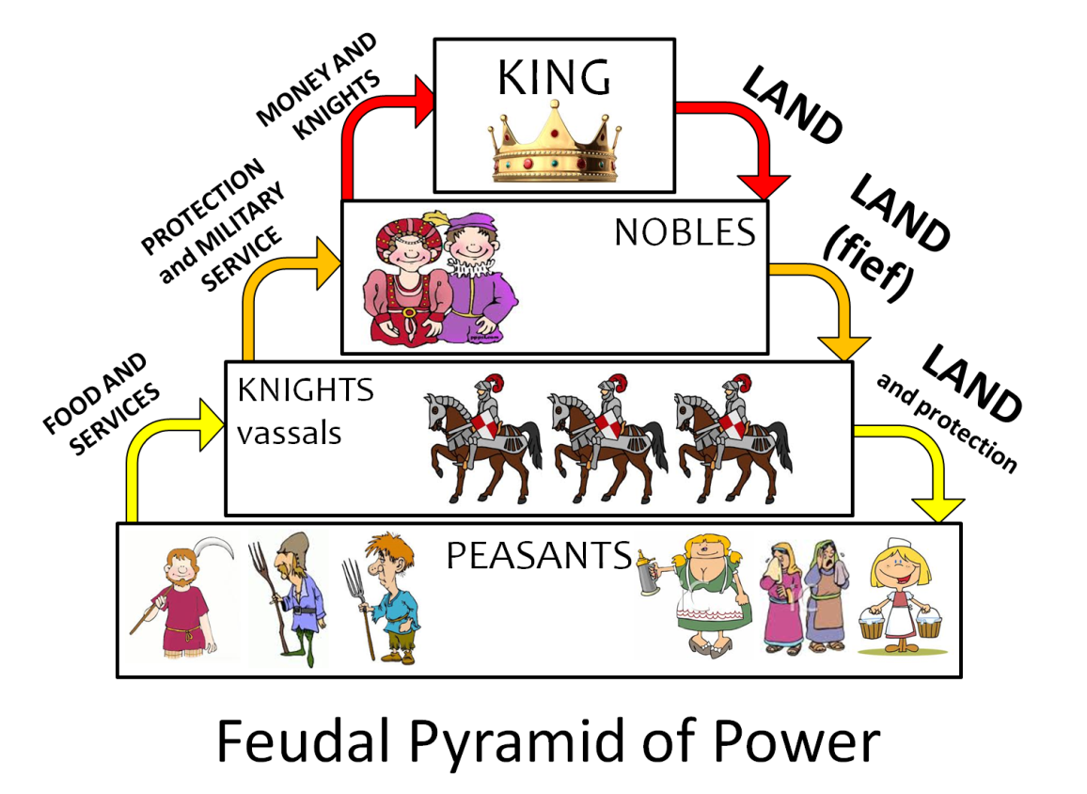
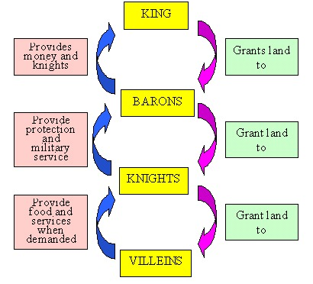
D
C
B
A
Directions – Examine the four diagrams on the other side of this page and answer the following questions.

1. List three things that all diagrams have in common - __________________________________________________

_________________________________________________ __________________________________________________

2. List two significant differences between the diagrams:

_________________________________________________ __________________________________________________

3. Use the information in the diagrams to come up with a definition of feudalism - _________________________________

______________________________________________________________________________________________________

4. Write one or two questions you still have about feudalism - _________________________________________________

______________________________________________________________________________________________________

5. List two sets of words that probably mean the same thing, based on the way they are used in the diagrams -

__________________and ______________________ __________________and ______________________

6. If you could only look at one diagram of feudalism, which of the four would be most useful? A B C D

Why? _____________________________________________________________________________________________

7. If you could only look at one diagram of feudalism, which of the four would be least useful? A B C D

Why? _____________________________________________________________________________________________

8. On a separate sheet, create your own diagram that includes the main classes of people under feudalism and explains
how feudalism worked. You may “borrow” ideas from the four diagrams, but you may not simply copy one of them.

