The Science Fiction Stories of Jules Verne
From the Earth to the Moon
After the American Civil War, two men from the same Baltimore Gun Club argue over whether a cannon can shoot a projectile (a thrown object) to the moon. The Gun Club is where rich men meet to appreciate weapons of all kinds (especially cannons). Its president has the ridiculous name of Impey Barbicane, and it’s his idea that a cannon can shoot a projectile so that it reaches the moon. Members from his society decide where the projectile will be shot, the dimensions and makings of both the cannon and the projectile, and which kind of powder are they to use.
But someone disagrees. He is an old enemy of Barbicane, a Captain Nicholl of Philadelphia. He ridicules the idea and bets a lot of money that Barbicane can’t do it. Nicholl has bet $1000 that Barbicane can’t raise the millions of dollars it will take to launch this projectile. But Barbicane does it, receiving $5,500,000 in donations (Verne has USA giving 4 million dollars, while England gives nothing, because it is jealous of American science).
After deciding the place for the launch (incredibly, Verne has the launch set at Stone's Hill in "Tampa Town", Florida; predating Kennedy Space Center's placement in Florida by almost 100 years), the Gun Club travels there and starts the construction of the Columbiad cannon. The excavation makes a 900-foot-deep and 60-foot-wide circular hole, which is made in the nick of time, but a surprise awaits Barbicane: Michel Ardan, a French adventurer, plans to travel aboard the projectile.
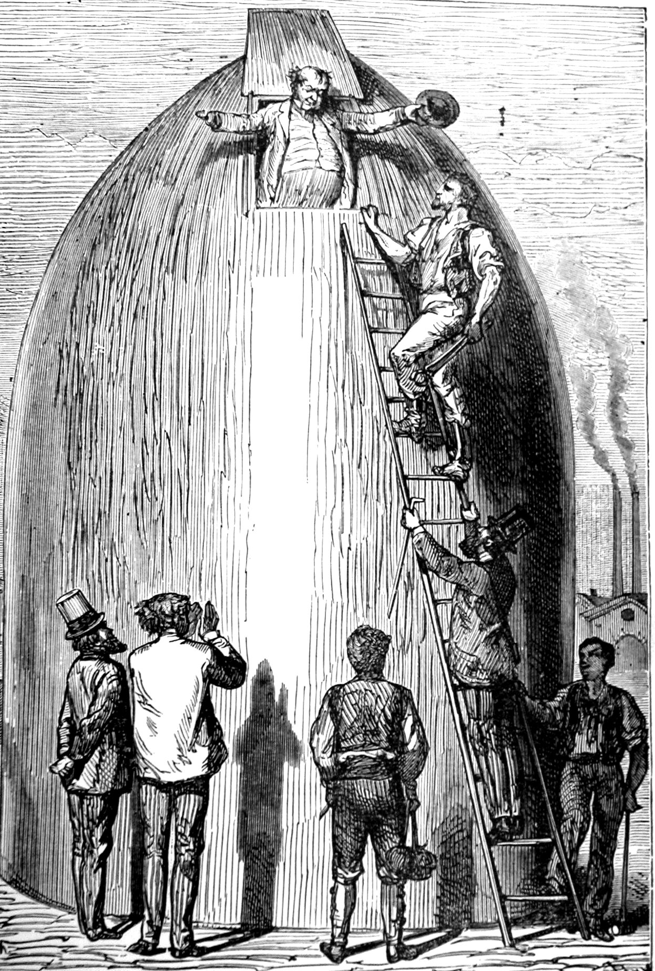
During a meeting between Ardan, the Gun Club, and the inhabitants of Florida, Nicholl appears and challenges Barbicane to a duel. The duel is stopped when Ardan meets the rivals in the forest where they have agreed to duel. Meanwhile, Barbicane finds the solution to the problem of surviving the incredible acceleration that the explosion would cause. Ardan suggests that Barbicane and Nicholl travel with him in the projectile, and the offer is accepted.
In the end, the projectile is successfully launched, but the destinies of the three astronauts are left inconclusive. The sequel, Around the Moon, deals with what happens to the three men in their travel from the earth to the moon.
Journey to the Center of the Earth
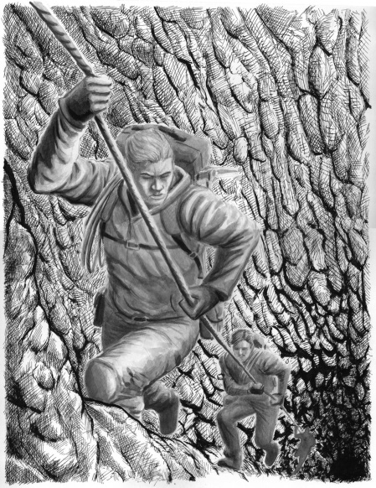
After decoding a scrap of paper he found in an old book, Professor Hardwigg takes his nephew Harry to an old volcano to see if it is possible to reach the core of the Earth. With a strong man named Hans from Iceland as their guide, the party undertakes the rugged journey up to the mountain. Once there, the three descend into the crater and after several days determine which of three shafts is the one through which they can make their descent. Aided by Hans' knowledge of how to use ropes they travel downward more than a mile the first day. The Professor explains that they are now at sea level and the real journey is just beginning.
They run across a dead end and when their water runs out, Harry collapses and assumes they will return to the surface. Although the Professor shows concern for Harry, he asks for one more day to find water before they abandon the journey. They select a different route and soon discover water. After they have descended 21 miles below the earth’s surface, Harry is lost for four days and after much suffering, is reunited with his uncle Hans.
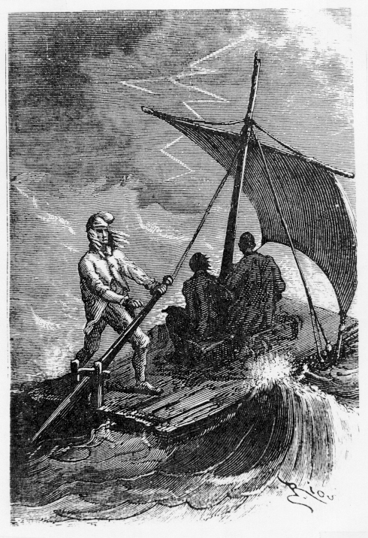
As Harry is recovering, he hears the sound of waves and thinks he sees light. In fact, the three have arrived at what they name the Central Sea, a vast underground body of water. At this point in the novel (Chapter 27) scientific wonders appear regularly. Exploring the area around the sea, the travelers find what looks like a forest but is actually forty foot mushrooms. The Professor explains to the astounded Harry how it is possible for plants to live beneath the earth. They continue their exploration of the area, finding bones of mastodons and other evidence of plant and animal life.
The Professor decides that they must cross the ocean to continue their descent even further into the earth. They build a raft, and when crossing the Sea, they fish and pull out a fish long thought extinct. During their trek across this impossibly large sea, they see amazing sights: two huge underwater monsters surface, battle, and almost swamp the raft. The three adventures spot an island with a boiling water geyser. A storm that strikes with fury and rages on for several days. A fire ball jumps onto the raft, destroys the mast and sail, and threatens them with its electric power. The raft is thrown onto shore by the storm.
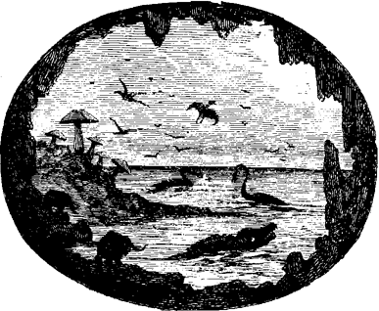
Exploring this area which is farther along the coast than their starting point, the Professor and Harry find enormous shells as long as fifteen feet and encounter a huge field of bones. Harry thinks the bones might contain the whole history of animal life. The Professor is delighted when they find a human skull. Harry shares his understanding of the importance of his uncle's find by describing what was happening in the world of paleontology or the science of fossil life. He discusses the views in Europe at that time that man's origins were even more ancient than had been previously believed. Then the two find more and more skeletons and wonder if these humans always lived beneath the earth or had ever lived on it.
Continuing their explorations they come across a beautiful forest of ferns and pines lacking color. They spot gigantic animals such as elephants and in the distance see a twelve-foot tall human being. Afraid of confrontation, they leave the area with many questions about man's origins. As they retrace their steps to the beach and the raft, Harry spots a rusted dagger that used to belong to another explorer from a couple hundred years before who wrote the old book that started this adventure. They enter the passage only to discover that it is blocked by solid granite.
The three decide to blast their way into the tunnel. They set the charge and retreat to the raft. The explosion opens a chasm that appears to be swallowing the Central Sea. They are thrown down on the raft and swept along with the rushing waters. Harry estimates their speed to be at least one hundred miles an hour as they are drawn deeper into the blackness of the center of the earth. Their fall is stopped by what appears to be a water spout.
As Harry half dreams, he thinks the raft has landed and he is in a small cave. A crocodile-shark monster and a huge ape come towards him, stop when they see each other, and engage in fierce battle. As the survivor comes towards Harry, he wakes and realizes he is still on the raft but that it is now ascending as the waters are pushed up a narrow shaft. Harry is consumed by hunger but the rising temperature in the shaft becomes his main concern, and the party soon discovers that the liquid beneath the raft is boiling hot. The Professor explains that an eruption is about to take place, and they are on top of the lava flow hurtling towards the earth's surface.
Harry awakes to find Hans supporting him on a mountainside. While making their way down, they learn from a young shepherd that they are on the island of Stromboli in Italy.
Once back in Germany, the three are treated like heroes and the Professor's achievements are recognized.
20,000 Leagues Under the Sea
The story opens in the year 1866. Everyone in Europe and America is talking about a mysterious creature that has been sinking ships. Finally, the United States government decides to intervene and commissions the Abraham Lincoln to capture and identify the creature. On board the ship are Pierre Aronnax, a renowned scientist along with his manservant, Conseil, and Ned Land the king of harpooners.
The Abraham Lincoln is attacked by the creature. Aronnax, Conseil and Land go overboard. The three men find themselves on top of the mysterious creature, which is actually a submarine vessel. They are taken on board and placed in a cell.
The men meet Captain Nemo, the commander of the vessel, known as the Nautilus. He tells them they can stay on board the ship and enjoy freedom as long as they return to the cell if asked. They are never to leave the vessel again. Ned Land says he will not promise that he will not try to escape.
Captain Nemo treats the men, especially Aronnax, very well. They are clothed and fed and may wander around the vessel at their leisure. Aronnax is thrilled by Nemo’s vast library. The men spend their time observing sea life through observation windows. Aronnax studies and writes about everything he sees.
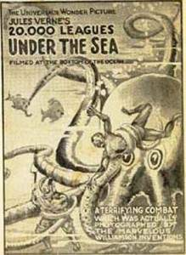
During their time on the Nautilus, the men experience many exciting adventures. They hunt in underwater forests, visit an island with angry natives, visit the lost city of Atlantis, and fish for giant pearls. However, there are also many distressing events coupled with the erratic behavior of Captain Nemo. One night the men are asked to return to their cell. They are given sleeping pills and awake the next morning very confused. Nemo asks Aronnax to look at a crewman who has been severely injured. The man later dies and they bury him in an underground cemetery, where many other crewmen have been laid to rest.
On a voyage to the South Pole, the Nautilus becomes stuck in the ice. Everyone must take turns trying to break a hole in the ice so the vessel can get through. The ship almost runs out of its oxygen supply and the men grow tired and light headed. However, they escape just in time.
Another time, the vessel sails through an area heavily populated by giant squid, when a giant squid gets stuck in the propeller of the submarine. The men and the crew must fight off the squid with axes because they cannot be killed with bullets. While fighting, a crewmember is killed by a squid. Nemo is moved to tears.
The rising action of the story begins with Nemo’s attack on a warship. Aronnax does not know to which nation the warship belongs, but he is horrified when Captain Nemo sinks it. The men decide they must escape at all costs.
One night, while off the coast of Norway, Aronnax, Conseil and Land plan a rash escape. To their dismay they realize they are heading toward a giant whirlpool—one that no ship has ever survived. Amazingly, in only a small dinghy they emerge safely. They awake in the hut of a fisherman. At the conclusion of the story, Aronnax is awaiting his return to France and rewriting his memoirs of his journey under the sea.

