Lovecraft's Mythos
Lovecraft's stories had a profound influence on the emerging field of alternative history. Read an excerpt from the story that canonized the Cthulhu Mythos.
by H. P. Lovecraft
from "Call of Cthulhu" (1926)
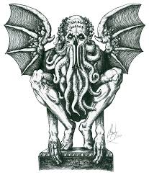
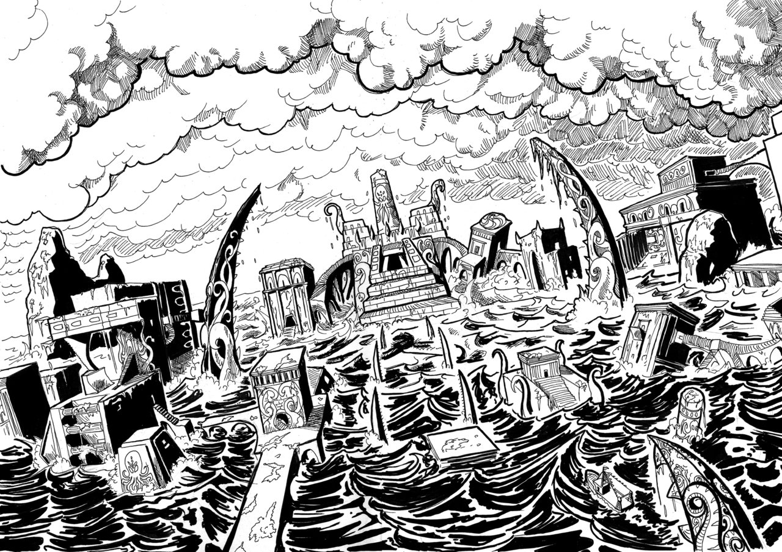
Examined at headquarters after a trip of intense strain and weariness, the prisoners all proved to be men of a very low, mixed-blooded, and mentally aberrant type… Degraded and ignorant as they were, the creatures held with surprising consistency to the central idea of their loathsome faith.
They worshipped, so they said, the Great Old Ones who lived ages before there were any men, and who came to the young world out of the sky. Those Old Ones were gone now, inside the earth and under the sea; but their dead bodies had told their secrets in dreams to the first men, who formed a cult which had never died. This was that cult, and the prisoners said it had always existed and always would exist, hidden in distant wastes and dark places all over the world until the time when the great priest Cthulhu, from his dark house in the mighty city of R'lyeh under the waters, should rise and bring the earth again beneath his sway. Some day he would call, when the stars were ready, and the secret cult would always be waiting to liberate him.
Meanwhile no more must be told. There was a secret which even torture could not extract. Mankind was not absolutely alone among the conscious things of earth, for shapes came out of the dark to visit the faithful few. But these were not the Great Old Ones. No man had ever seen the Old Ones. The carven idol was great Cthulhu, but none might say whether or not the others were precisely like him. No one could read the old writing now, but things were told by word of mouth. The chanted ritual was not the secret - that was never spoken aloud, only whispered. The chant meant only this: "In his house at R'lyeh dead Cthulhu waits dreaming."
Only two of the prisoners were found sane enough to be hanged, and the rest were committed to various institutions. All denied a part in the ritual murders, and averred that the killing had been done by Black Winged Ones which had come to them from their immemorial meeting-place in the haunted wood. But of those mysterious allies no coherent account could ever be gained. What the police did extract, came mainly from the immensely aged mestizo named Castro, who claimed to have sailed to strange ports and talked with undying leaders of the cult in the mountains of China.
Old Castro remembered bits of hideous legend that paled the speculations of theosophists and made man and the world seem recent and transient indeed. There had been eons when other Things ruled on the earth, and They had had great cities. Remains of Them, he said the deathless Chinamen had told him, were still be found as Cyclopean stones on islands in the Pacific. They all died vast epochs of time before men came, but there were arts which could revive Them when the stars had come round again to the right positions in the cycle of eternity. They had, indeed, come themselves from the stars, and brought Their images with Them.
These Great Old Ones, Castro continued, were not composed altogether of flesh and blood. They had shape - for did not this star-fashioned image prove it? - but that shape was not made of matter. When the stars were right, They could plunge from world to world through the sky; but when the stars were wrong, They could not live. But although They no longer lived, They would never really die. They all lay in stone houses in Their great city of R'lyeh, preserved by the spells of mighty Cthulhu for a glorious surrection when the stars and the earth might once more be ready for Them. But at that time some force from outside must serve to liberate Their bodies. The spells that preserved them intact likewise prevented Them from making an initial move, and They could only lie awake in the dark and think whilst uncounted millions of years rolled by. They knew all that was occurring in the universe, for Their mode of speech was transmitted thought. Even now They talked in Their tombs. When, after infinities of chaos, the first men came, the Great Old Ones spoke to the sensitive among them by molding their dreams; for only thus could Their language reach the fleshly minds of mammals.
Then, whispered Castro, those first men formed the cult around tall idols which the Great Ones shewed them; idols brought in dim eras from dark stars. That cult would never die till the stars came right again, and the secret priests would take great Cthulhu from His tomb to revive His subjects and resume His rule of earth. The time would be easy to know, for then mankind would have become as the Great Old Ones; free and wild and beyond good and evil, with laws and morals thrown aside and all men shouting and killing and reveling in joy. Then the liberated Old Ones would teach them new ways to shout and kill and revel and enjoy themselves, and all the earth would flame with a holocaust of ecstasy and freedom. Meanwhile the cult, by appropriate rites, must keep alive the memory of those ancient ways and shadow forth the prophecy of their return.
In the elder time chosen men had talked with the entombed Old Ones in dreams, but then something happened. The great stone city R'lyeh, with its monoliths and sepulchers, had sunk beneath the waves; and the deep waters, full of the one primal mystery through which not even thought can pass, had cut off the spectral intercourse. But memory never died, and the high-priests said that the city would rise again when the stars were right. Then came out of the earth the black spirits of earth, moldy and shadowy, and full of dim rumors picked up in caverns beneath forgotten sea-bottoms. But of them old Castro dared not speak much. He cut himself off hurriedly, and no amount of persuasion or subtlety could elicit more in this direction. The size of the Old Ones, too, he curiously declined to mention. Of the cult, he said that he thought the center lay amid the pathless desert of Arabia, where Irem, the City of Pillars, dreams hidden and untouched. It was not allied to the European witch-cult, and was virtually unknown beyond its members. No book had ever really hinted of it, though the deathless Chinamen said that there were double meanings in the Necronomicon of the mad Arab Abdul Alhazred which the initiated might read as they chose, especially the much-discussed couplet:
That is not dead which can eternal lie,
And with strange eons even death may die.

