Your Mythology Story
We have learned of a multitude of different ancient mythologies…
…and even about modern mythological heroes.
Now, your task is to create a story that pits one figure of a mythology against another of a different mythology. Who will survive?
- First, identify the two figures (or more):
__________________________________________ of the ___________________ mythology
AND
__________________________________________ of the ___________________ mythology

- What kind of a conflict will they be engaged in?
  - Fight to the death? c. Debate? e. Solving a mystery?
  - Teaming up to fight something? d. Game/Contest? f. Other? ___________

- In what setting will this story takes place? ____________________________________________

- How will it end? ________________________________________________________________

Now, you must decide how your Mythology Story will be created. You have three options:
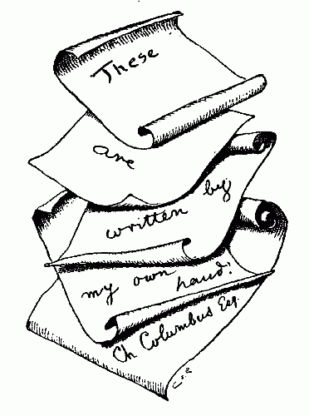
- Written or typed narrative. It should…
  - be at least two full pages (or the front and back of a 8.5 x 11 paper).
  - include the beginning of how the two figures meet, the conflict as it unfolds, and the ending of the fight.
  - , if you decide to include an optional picture, be hand-drawn art and cannot take up more than one fourth of one page.
  - include few spelling or grammatical mistakes.
  - have a fitting title.
  - be written or typed neatly.
  - be original—no copying and pasting at all.

- Video. It should…
  - be at least 1 minute long and no more than 4 minutes long.
  - include an introduction of who each character is.
  - involve good enough sound and picture quality, as well as dialogue.
  - have credits at the end of the footage.
  - include a title of the movie at the beginning.
  - not include any footage or clips from any other movie or television show.

- Comic. It should…
  - be at least one full page of 10 or more panels.
  - be colored in, every panel/box.
  - identify the characters, the conflict, and the conclusion.
  - be drawn neatly with the use of rulers or straight edges.
  - be authentic with no inclusion of copyrighted material.

Your Mythology Story will be due in class on Wednesday, 9/23.
- If it is digital, you may email it to your teacher (randerson3@wcpss.net), bring it in by flashdrive, or save it to your account.
- It is a hard copy, you may present it to the teacher on Wednesday.
- All stories are expected to be presented to the class.

