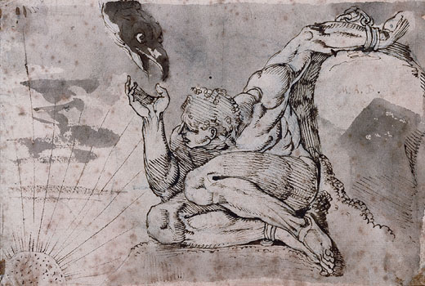  Prometheus  The Creation of Man by Prometheus (by J.M. Hunt)  Prometheus and Epimetheus were spared imprisonment in Tartarus because they had not fought with their fellow Titans during the war with the Olympians. They were given the task of creating man. Prometheus shaped man out of mud, and Athena breathed life into his clay figure.  Prometheus had assigned Epimetheus the task of giving the creatures of the earth their various qualities, such as swiftness, cunning, strength, fur, and wings. Unfortunately, by the time he got to man Epimetheus had given all the good qualities out and there were none left for man. So Prometheus decided to make man stand upright as the gods did and to give him fire.  Prometheus loved man more than the Olympians, who had banished most of his family to Tartarus. So when Zeus decreed that man must present a portion of each animal he scarified to the gods, Prometheus decided to trick Zeus. He created two piles, one with the bones wrapped in juicy fat, the other with the good meat hidden in the hide. He then bade Zeus to pick. Zeus picked the bones. Since he had given his word, Zeus had to accept this pile as his share for future sacrifices. In his anger over the trick, he took fire away from man. However, Prometheus lit a torch from the sun and brought it back again to man. Zeus was enraged that man again had fire. He decided to inflict a terrible punishment on both man and Prometheus.  To punish man, Zeus had Hephaestus create a mortal of stunning beauty. The gods gave the mortal many gifts of wealth. He then had Hermes give the mortal a deceptive heart and a lying tongue. This creation was Pandora, the first woman. A final gift was a jar which Pandora was forbidden to open. Thus completed, Zeus sent Pandora down to Epimetheus, who was staying amongst the men.  Prometheus had warned Epimetheus not to accept gifts from Zeus, but Pandora's beauty was too great and he allowed her to stay. Eventually, Pandora's curiosity about the jar she was forbidden to open became intolerable to her. She opened the jar and out flew all manner of evils, sorrows, plagues, and misfortunes. However, the bottom of the jar held one good thing - hope.  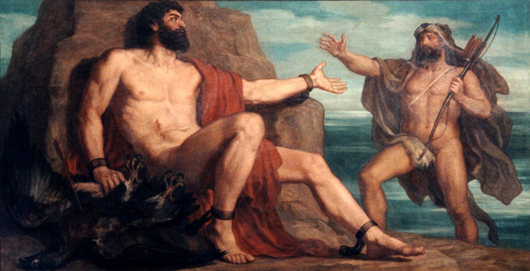  Zeus was angry at Prometheus for three things: being tricked by the sacrifices, stealing fire for man, and refusing to tell Zeus which of Zeus's children would dethrone him. Zeus had his servants, Force and Violence, seize Prometheus, take him to the Caucasus Mountains, and chain him to a rock with unbreakable adamantine chains. Here he was tormented day and night by a giant eagle tearing at his liver. Zeus gave Prometheus two ways out of this torment. He could tell Zeus who the mother of the child that would dethrone him was, or meet two conditions. The first was that an immortal must volunteer to die for Prometheus, and the second was that a mortal must kill the eagle and unchain him. Eventually, Chiron the Centaur agreed to die for him and Heracles killed the eagle and unbound him. |  | Prometheus,  by Henry Fusili, 1770-71
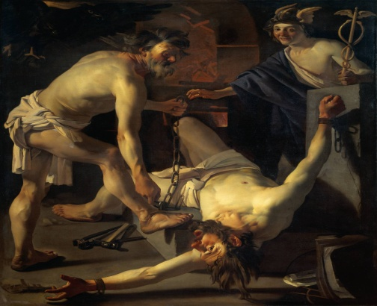
Prometheus Being Chained by Vulcan,
by Dirck Van Baburen, 1623

