Ragnarok

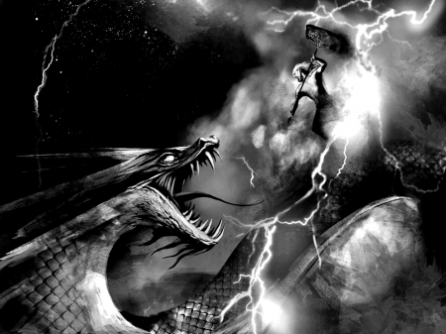
In Asgard there is a rooster, every morning it crows loudly to wake the gods. One day there will come a morning when it will crow for the last time, that time is known as Ragnarok when all will suffer and everything be brought to ruin. The first to notice shall be man, brother will fight brother and all the boundaries that exist shall crumble. It will start with a trembling in the earth, with that first tremble Loki shall break free of his bonds, and lead the undead in a battle upon a ship made of dead men's nails against the gods themselves. Fenrir, the great wolf shall break free from its fetter Gleipnir. A vast winter shall come, not a single winter but three rolled into one unyielding cold with no summer between. Surt, jotun-king and the one who waits at Muspeilheim shall come forth from his fiery home and go to war with the gods, all the nine worlds shall be seared by his flames. At his side shall walk Fenrir, its jaws dripping with the blood of the dead. The Midgard Serpent shall free its self from its tail and rise up from the ocean, spewing poison over land and sea. And the heaven shall offer no comfort, for the sun and the moon shall be swallowed whole by the wolves that chase them heralding the end.

Ragnarok

In Asgard there is a rooster, every morning it crows loudly to wake the gods. One day there will come a morning when it will crow for the last time, that time is known as Ragnarok when all will suffer and everything be brought to ruin. The first to notice shall be man, brother will fight brother and all the boundaries that exist shall crumble. It will start with a trembling in the earth, with that first tremble Loki shall break free of his bonds, and lead the undead in a battle upon a ship made of dead men's nails against the gods themselves. Fenrir, the great wolf shall break free from its fetter Gleipnir. A vast winter shall come, not a single winter but three rolled into one unyielding cold with no summer between. Surt, jotun-king and the one who waits at Muspeilheim shall come forth from his fiery home and go to war with the gods, all the nine worlds shall be seared by his flames. At his side shall walk Fenrir, its jaws dripping with the blood of the dead. The Midgard Serpent shall free its self from its tail and rise up from the ocean, spewing poison over land and sea. And the heaven shall offer no comfort, for the sun and the moon shall be swallowed whole by the wolves that chase them heralding the end.
Upon that day, Heimdall, the watcher and guardian of Bifrost shall blow his great horn, and the sound shall echo throughout the nine worlds so that all shall know that the time has come, and the gods shall take up their weapons and ride into battle and to their death.
As Odin rides into battle challenging Fenrir, the wolf swallows him whole, Thor battling the fearsome Midgard Serpent is unable to help. Vidar, Odin's son, in vengeance rips Fenrir apart, but too late for Odin is already dead. Thor kills the Midgard Serpent but before he takes nine paces he shall die from the serpent’s poison. Heimdall and Loki shall face each other and both shall die. Surt will kill Freyr, who is without his sword that fights by itself.
The very sky shall burn with flame, and the earth shall sink into the sea. Death shall come to all manner of things, to the gods, giants, dwarfs, elves, men, women and children. All but two shall die, those two shall be Lif and Lifthrasir, who will be hidden by Yggdrasil, the world tree. From them mankind shall be reborn, and earth shall rise for a second time. Odin's sons Balder and Hoder will return to life from the Underworld, and all shall be at peace again. And the children of Lif and Lifthrasir shall walk the earth and wonder about the gods who died so long ago.

Upon that day, Heimdall, the watcher and guardian of Bifrost shall blow his great horn, and the sound shall echo throughout the nine worlds so that all shall know that the time has come, and the gods shall take up their weapons and ride into battle and to their death.
As Odin rides into battle challenging Fenrir, the wolf swallows him whole, Thor battling the fearsome Midgard Serpent is unable to help. Vidar, Odin's son, in vengeance rips Fenrir apart, but too late for Odin is already dead. Thor kills the Midgard Serpent but before he takes nine paces he shall die from the serpent’s poison. Heimdall and Loki shall face each other and both shall die. Surt will kill Freyr, who is without his sword that fights by itself.
The very sky shall burn with flame, and the earth shall sink into the sea. Death shall come to all manner of things, to the gods, giants, dwarfs, elves, men, women and children. All but two shall die, those two shall be Lif and Lifthrasir, who will be hidden by Yggdrasil, the world tree. From them mankind shall be reborn, and earth shall rise for a second time. Odin's sons Balder and Hoder will return to life from the Underworld, and all shall be at peace again. And the children of Lif and Lifthrasir shall walk the earth and wonder about the gods who died so long ago.

