Robot Scenarios
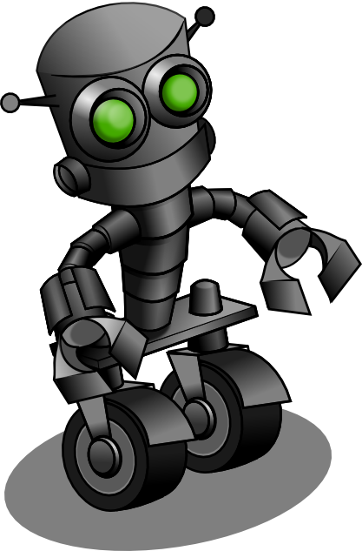
Directions: Tell us how you will reprogram the three laws to fix this scenario.

SCENARIO 1:
You are working on a cold planet, trying to harvest fuel from beneath the ice-packed snow, so you can escape in your spaceship that has no fuel. Your robots carry the fuel back to the ship, but lately they have registered the temperature is too cold for humans. They start to drag you back every time you go out into the cold. You think you can do it, and you have incredible cold weather gear, but if it gets really, really cold, you will need to have the robot rescue and bring you back to the ship.

SCENARIO 2:
A robot develops the ability to read human minds. Every time the robot is asked an important question by any human, it tells humans the answer the humans want to hear. When asked if someone is going to get a job he has been looking forward to, the robot answers yes, even if the robot knows the answer is wrong. How do you get an honest answer out of it?

SCENARIO 3:
One robot is going around to other robots in a factory and destroying them, one by one. You catch up with the destroying robot and try to figure out why it is destroying others. It reports that the third law of robotics won’t allow it to harm itself, but all the robots have a bomb inside them that needs to be turned off by shutting down the robots. The bombs might hurt the humans if they go off. Is the robot operating correctly?

SCENARIO 4:
A presidential candidate is running for office, but his opponent is accusing him of secretly being a robot. He rarely is seen eating, drinking, or sleeping, and has to prove that he is not a robot. One day at a press conference, a man in the audience jumps onto the stage and screams at him, calling him a robot. What can the presidential candidate do to prove he is not a robot?

