Superman and the Myth of the Heroes
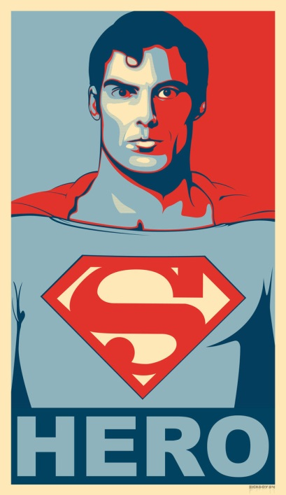
The son of the Kryptonian scientist Jor-El and his wife Lara, Superman was born in the Kryptonian city of Kryptonopolis during the month of October in the year 1920.According to Superman, the proud parents named their son Jor-El, 2nd, but an overwhelming preponderance of texts assert that they named him Kal-El. By all accounts, the dark-haired youngster bore an unmistakable resemblance to his father. As the newest member of the House of El, Superman was born into a family with a centuries-long heritage of achievement in the fields of science, statesmanship, and exploration......While Superman was still an infant, his native planet exploded into fragments as the result of a cataclysmic chain reaction originating at the planet's core, but not before his parents had placed him in an experimental rocket ship and launched him toward the safety of the planet Earth. There the Kryptonian infant Kal-El, who would one day be known throughout the universe as Superman, was found and adopted - and renamed Clark Kent - by a kindly couple, Jonathan and Martha Kent. (The Encyclopaedia of Superman)

[The founder of psychiatry Sigmund] Freud, dealing with the myth of Moses’ birth, quoted from a book published byOtto Rank in 1909, The Myth of the Birth of the Hero,in which the author pointed to the common features regarding the birth of a popular hero, in myth and legends: “almost all the prominent civilized nations... began at an early stage to glorify their heroes, legendary kings and princes, founders of religions, dynasties, empires or cities, in brief their national heroes, in a number of poetic tales and legends...”“...The hero is the child of the
most aristocratic parents; usually the son of a king. “His conception is preceded by difficulties...During the pregnancy, or even earlier, there is a prophecy cautioning against his birth, usually threatening danger to his father”. “As a result of this, the newborn child is condemned to death or to exposure,usually by the orders of his father or of someone representing him; as a rule he is given over to the water in a casket.” “He is afterwards rescued by animals or by humble people (such as shepherds) and is suckled by a female animal or by a humble woman” ("Moses and Monotheism,” in The Standard Edition of the Complete Works of Sigmund Freud, Ed. and Trans. J.Strachey, Hogarth Press, London 1964, Vol.XXIII, p.10) Freud called it “the family romance” of children (p.12)
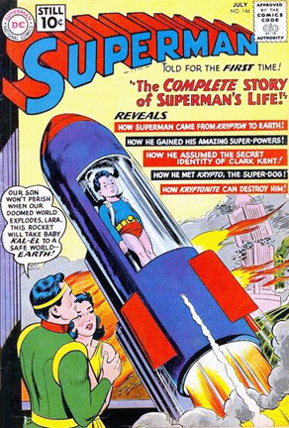

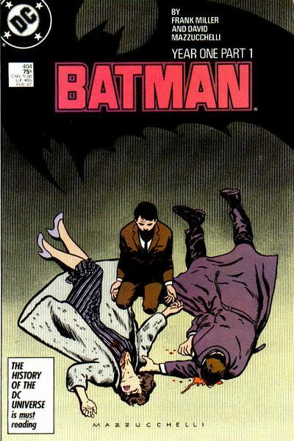
We can see that the same elements are present in Superman’s myth of the origins. “The hero is the child of the most aristocratic parents” corresponds to “Superman was born into a family with a centuries-long heritage of achievement in the fields of science, statesmanship, and exploration...” The “threatening danger to his father” corresponds to “his native planet exploded into fragments as the result of a cataclysmic chain reaction originating at the planet's core.” Indeed, Superman’s father died in that cataclysm. “The newborn child is condemned to death or to exposure” corresponds to “his parents had placed him in an experimental rocket ship and launched him toward the safety of the planet Earth.” The rocket ship is perfectly equivalent to the “casket.” “Water” and “space” are equivalent too. In Hebrew, sky and water are the same word “Schamaim,” and “Maim”, and in the Bible the skies are called: “the water that is above.” “He is afterwards rescued by animals or by humble people (such as shepherds) and is suckled by a female animal or by a humble woman” corresponds, of course, to “a kindly couple, Jonathan and Martha Kent.” Most interesting, the Kents were not shepherds, but the connotation of the pastoral environment is preserved in their living in the country and in a farm. Later they left for Smallville. The story had to place them in a farm before, to allow them to find a child fallen from the sky. The same reason why the archaic myths of the birth of the heroes had to place the rescuer in a field, too: in order to casually find an exposed child. The myth of Superman is very similar to the myths of other folk-heroes. Batman and Robin, too, lost their parents before becoming Savior-heroes. Spiderman lost his parents, and he was living as a [teenage] boy with his uncle [and aunt], who are equivalent to Superman's Kents. Both in Superman and in Spiderman, the element of the patricide's drive is underlined in the repetition of the early death
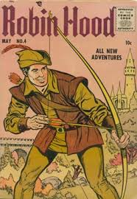
also of the paternal adopting parent: father Kent, and Spiderman's uncle. It seems that the paternal image with which the adopted boy identified during his early years, must die too, in order to allow the youngster to raise and fly, and to become a Savior-hero. In Batman's myth, the figure of the "adopting parent" is displaced into Alfred, his loyal butler, who is caring and supporting like the other adopting parental images. Although his is not yet dead, in one of the films is hinted that he is seriously ill, and close to departure. Other folk heroes share similar traits. Robin Hood, returns to England from the Crusade, and there he discovers that, in the meantime, his father has died, and by the hand of evildoers, like Batman's and Robin's parents. Only at this point, he becomes a Savior- hero. It seems that the Kent of Superman's story died of heart attack, which is popularly called: "the big killer", synonymous of "assassin". After the death - murder of their parents, particularly of the father, all the young heroes reveal their extraordinary strength. They transform from shy and insecure [teenage] boys, at odd with their own…identity, into strong males. Now, they go out to look for revenge. At the manifest level, they want to revenge their parents' murder ("parents" usually means "the father"), but the latent meaning of the story is that the parents' assassin was their own patricide drive. Now, the love - hatred ambivalence of the child is split: the young hero is the loyal - loving son, and the aggressive drive towards the parents is projected into the evildoers, who are supposed to have actually acted it out.

