Background to The Trojan War
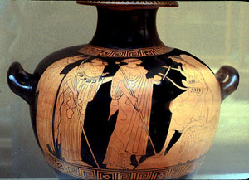
Once upon a time, around 1250 BC, toward the end of the Bronze Age in Greece, three goddesses were having an argument (said the Greeks). The goddesses Aphrodite, Athena, and Hera were arguing about which one of them was the most beautiful. They agreed to choose a human man and let him decide. More or less at random, the goddesses picked Paris, the youngest son of King Priam of Troy, to be their judge.
Each of the goddesses offered Paris a bribe to get him to vote for her. Athena offered him wisdom. Hera offered him power. But Aphrodite offered him the most beautiful woman in the world, and Paris voted for her.
So Aphrodite had to come through on her promise. She sent Paris to go visit the Greek king of Sparta, Menelaus (men-uh-LAY-us). Menelaus was married to Helen, who was the most beautiful woman in the world. Menelaus and Helen welcomed Paris kindly, and gave him dinner and let him stay the night in their house. But during the night Paris convinced Helen to run away with him (because Aphrodite made her agree). He took her back to Troy with him and married her, even though she was already married to Menelaus.
Judgment of Paris -Paris is on the right

The Iliad

Homer
"Sing, Goddess, of the anger of Achilles..."

The story of Homer's Iliad begins in the middle of the Trojan War, just at the end of the Bronze Age in Greece. We don't know if there ever really was a Trojan War, but even if there was, this is a story about it, not a real memory of it.
The Greeks believed that the Trojan War lasted for ten years, and this story happens in the tenth year of the war, when both sides were really sick of being at war, and the Greeks were sick of being away from home.

The Iliad begins with a fight between the leader of the Greeks, King Agamemnon of Mycenae, and the Greeks' best fighter, King Achilles (uh-KILL-eez), who could not be harmed by human weapons. (The Greeks lived in a lot of little city-states, and in the Bronze Age each one had its own king, but Agamemnon was leading them all during the war). The Greeks had won a battle and were splitting up the booty (the stuff they had captured). Everybody had a pile of stuff. Achilles had gotten a woman among his stuff, to be his slave, whose name was Briseis (brih-SAY-iss). But Agamemnon decided that HE wanted the pretty Briseis, and he just took her from Achilles, saying that he was the head of the army so he would do what he liked.
Well, Achilles was so angry that Agamemnon took Briseis from him that he refused to fight for the Greeks anymore and just sat in his tent and sulked. Without their best fighter, the Greeks started losing battles.

Finally Achilles' cousin and best friend Patroclos thought of an idea. He put on Achilles' famous armor and went out to fight. Both the Greeks and the Trojans thought Achilles had come back to the battle and the Greeks won a big victory, but Patroclos was killed in the fighting: he might dress like Achilles but he could not fight like him.
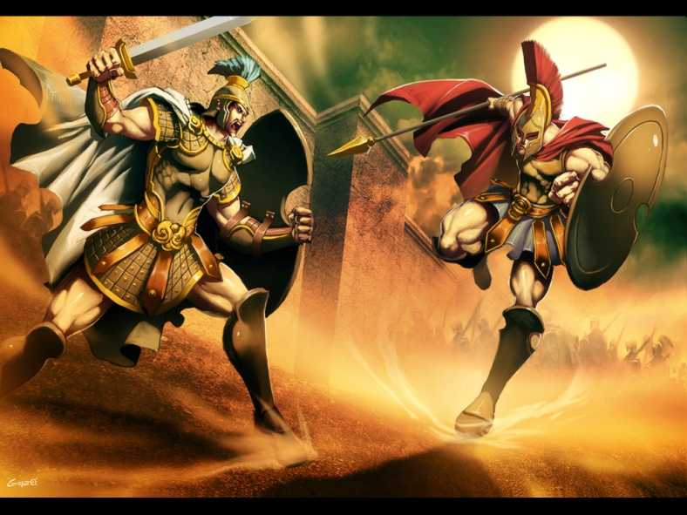
When Achilles heard that Patroclos was dead, he was ashamed of how he had been sulking. He agreed to fight again. Now the Greeks really started to win. So the best Trojan fighter, Prince Hector, came out from Troy to fight Achilles. They fought for a long time, but finally Achilles killed Hector.

Hector's father, King Priam, came to Achilles at night to ask for his son's body back, and Achilles gave it to him.

The Iliad ends here, but this is not the end of the story. After the events of the Iliad and the death of Hector, the Trojan War still wasn't over. Achilles was killed by Paris, brother of Hector, by shooting an arrow through the only part of the warrior’s body that was vulnerable: his heel. (Achilles was half-god, and was immune to any mortal attack because his divine mother had dipped his baby body into the gods’ river Styx by his heels. Where she held him, however did not touch the water and could still be harmed.) With Achilles’ death, neither the Greeks nor the Trojans seemed to be able to win, until one of the Greek kings, Odysseus of Ithaca, had an idea.
"Build a big wooden horse on wheels," he said, "big enough for a bunch of Greek soldiers to hide inside it." So the Greeks did. Then the Greeks all pretended to sail home (except the ones hiding inside the horse!). They acted like they had given up and left. But really they hid just around the corner.

Soon the Trojans found the horse. "What is it?" they asked each other. Nobody knew. (The Greek soldiers hiding inside kept very quiet). Then they found a Greek soldier hiding nearby. He said (though this was part of the trick) that the other Greeks hated him and they had left him behind. So the Trojans asked him what the horse was for. He said it was an offering to Athena.

Well, the Trojans didn't want to upset Athena either, so they rolled the big horse into the city of Troy. It was so big it wouldn't go through the gate, and they had to tear down a piece of the city wall to get it in. They left it at the temple of Athena, and then the Trojans had a big party to celebrate the end of the war. (Still the Greek soldiers inside the horse kept very quiet).

Finally everyone fell asleep, and NOW the Greek soldiers came out of the Trojan Horse and killed the guards on the walls. They signaled to the other Greeks to come attack Troy. They could get in now because the walls were torn down. There was a big battle and the Greeks won. All the Trojan men were killed, and all the women and children were taken back to Greece as slaves.

This story does not actually appear in the Iliad or the Odyssey, but it is told in Virgil's Aeneid and in other ancient sources.

The Odyssey

Homer

Ten years have passed since the fall of Troy, and the Greek hero Odysseus still has not returned to his kingdom in Ithaca. A large and rowdy mob of suitors who have overrun Odysseus’s palace and pillaged his land continue to court his wife, Penelope. She has remained faithful to Odysseus. Prince Telemachus, Odysseus’s son, wants desperately to throw them out but does not have the confidence or experience to fight them. One of the suitors, Antinous, plans to assassinate the young prince, eliminating the only opposition to their dominion over the palace.

Unknown to the suitors, Odysseus is still alive. The beautiful nymph Calypso, possessed by love for him, has imprisoned him on her island, Ogygia. He longs to return to his wife and son, but he has no ship or crew to help him escape. While the gods and goddesses of Mount Olympus debate Odysseus’s future, Athena, Odysseus’s strongest supporter among the gods, resolves to help Telemachus. Disguised as a friend of the prince’s grandfather, Laertes, she convinces the prince to call a meeting of the assembly at which he reproaches the suitors. Athena also prepares him for a great journey to Pylos and Sparta, where the kings Nestor and Menelaus, Odysseus’s companions during the war, inform him that Odysseus is alive and trapped on Calypso’s island. Telemachus makes plans to return home, while, back in Ithaca, Antinous and the other suitors prepare an ambush to kill him when he reaches port.

On Mount Olympus, Zeus sends Hermes to rescue Odysseus from Calypso. Hermes persuades Calypso to let Odysseus build a ship and leave. The homesick hero sets sail, but when Poseidon, god of the sea, finds him sailing home, he sends a storm to wreck Odysseus’s ship. Poseidon has harbored a bitter grudge against Odysseus since the hero blinded his son, the Cyclops Polyphemus, earlier in his travels. Athena intervenes to save Odysseus from Poseidon’s wrath, and the beleaguered king lands at Scheria, home of the Phaeacians. Nausicaa, the Phaeacian princess, shows him to the royal palace, and Odysseus receives a warm welcome from the king and queen. When he identifies himself as Odysseus, his hosts, who have heard of his exploits at Troy, are stunned. They promise to give him safe passage to Ithaca, but first they beg to hear the story of his adventures.

Odysseus spends the night describing the fantastic chain of events leading up to his arrival on Calypso’s island. He recounts his trip to the Land of the Lotus Eaters where his men were luled to sleep by eating the fruit on that island, his battle with Polyphemus the Cyclops in which he barely escaped by blinding the monster’s one eye, his love affair with the witch-goddess Circe who turned men into pigs and other animals with her magic, his temptation by the deadly Sirens that lured men to their deaths with their voices, his journey into Hades to consult the prophet Tiresias, and his fight with the sea monster Scylla and its neighbor Charybdis. He related how he had lost his ship and his remaining men when they had stolen one of the sacred cows from the island of Helios, the sun. Now he was the last survivor of all his crew. He had kept alive at sea by drinking the blood of seagulls until he had reached Calypso’s island. When he finishes his story, the Phaeacians return Odysseus to Ithaca, where he seeks out the hut of his faithful swineherd, Eumaeus. Though Athena has disguised Odysseus as a beggar, Eumaeus warmly receives and nourishes him in the hut. He soon encounters Telemachus, who has returned from Pylos and Sparta despite the suitors’ ambush, and reveals to him his true identity. Odysseus and Telemachus devise a plan to massacre the suitors and regain control of Ithaca.

When Odysseus arrives at the palace the next day, still disguised as a beggar, he endures abuse and insults from the suitors. The only person who recognizes him is his old nurse, Eurycleia, but she swears not to disclose his secret. Penelope takes an interest in this strange beggar, suspecting that he might be her long-lost husband. Quite crafty herself, Penelope organizes an archery contest the following day and promises to marry any man who can string Odysseus’s great bow and fire an arrow through a row of twelve axes—a feat that only Odysseus has ever been able to accomplish. At the contest, each suitor tries to string the bow and fails. Odysseus steps up to the bow and, with little effort, fires an arrow through all twelve axes. He then turns the bow on the suitors. He and Telemachus, assisted by a few faithful servants, kill every last suitor.

Odysseus reveals himself to the entire palace and reunites with his loving Penelope. He travels to the outskirts of Ithaca to see his aging father, Laertes. They come under attack from the vengeful family members of the dead suitors, but Laertes, reinvigorated by his son’s return, successfully kills Antinous’s father and puts a stop to the attack. Zeus dispatches Athena to restore peace. With his power secure and his family reunited, Odysseus’s long ordeal comes to an end.

Questions:
- Why are the Iliad and the Odyssey so famous throughout history?
- Describe the main characters of the Iliad in a sentence each.
- Describe the main characters of the Odyssey in a sentence each.
- What do you think is the moral of the Iliad?
- What do you think is the moral of the Odyssey?
- Greeks believed that every man had a fatal flaw: what was Achilles’ fatal flaw? What was Odysseus’?
- How many years total did it take for Odysseus to return home?
- Nowadays any long adventurous journey is called an “odyssey.” Make a connection: name anyone else who has gone on an odyssey, and describe his or her journey.
- Which was the worst of the monsters that Odysseus faced?
- Why was Achilles almost-undefeatable?

