Week 9
Monday Warm Up: Why is your Medieval Job the best there is?

Tuesday Warm Up: What is the most popular book in the world? Why?

Wednesday Warm Up: What is the biggest difference between the Middle Ages and today?

Thursday Warm Up: What were cities like in the Middle Ages?

Friday Warm Up: Why aren’t knights in battle today?
Knight/Marines commercial
Week 8
Monday Warm Up: What would you like to have on your tombstone?

Tuesday Warm Up: What happened to Joan of Arc? (Guess.)

Wednesday Warm Up: What would cause a war for over a hundred years?

Thursday Warm Up: Do you think Joan of Arc really heard voices from God, or was she crazy? Or is there a third option?

Friday Warm Up: Draw your Guild sign.

Alternative Warm Up: Describe three things your trade makes or is famous for.
Week 7
Monday Warm Up: Compare Jesus’ words with those of the Crusaders who fought for him:
Jesus: “You have heard it was said, ‘Love your neighbor and hate your enemy.’ But I tell you, love your enemies and pray for those who persecute you, that you may be children of your Father in heaven.” (Matthew 5:43-45)
Crusaders: “Deus le volt!” = “God wills it!” (when encouraged to go to war with Muslims in the Holy Lands)
Tuesday Warm Up: Guess how many Crusades there were total.
Wed. Warm Up: If your friend had the Bubonic Plague (BD) what would his symptoms be?
Thursday Warm Up: You’ve learned about knights’ weapons. Which would be your favorite to use?

Friday Warm Up: What could be some good effects of the Black Death?

Week 6
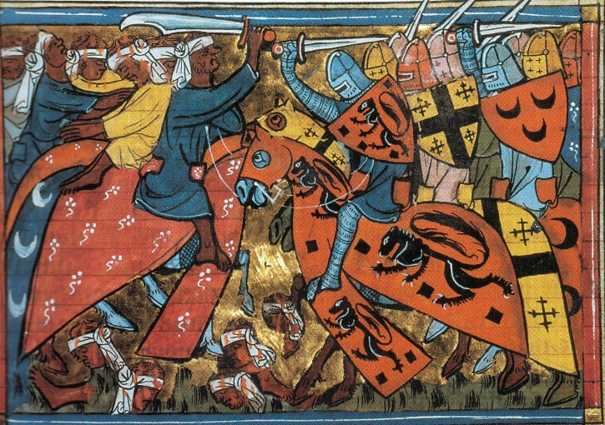
Monday Warm Up: Write a one-sentence story explaining why this is happening.

Tuesday Warm Up: Why was the Church stronger in the Middle Ages than it is today?
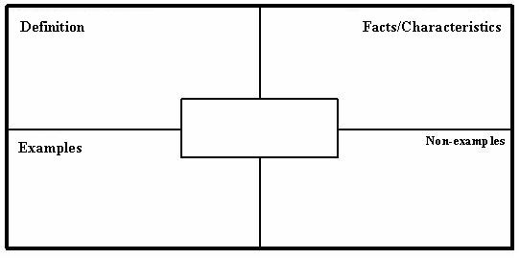
Wednesday Warm Up: Name three of the most fascinating people during the Middle Ages, and why.
Thursday Warm Up: Make a Frayer Model for one of these words:
Simony, Indulgence, Tithe, Excommunication
Friday Warm Up: Identify who in this class you could defeat in knightly single combat, but don’t show your list to anyone.

Week 5
Monday Warm Up: Design what your knight’s shield would look like.
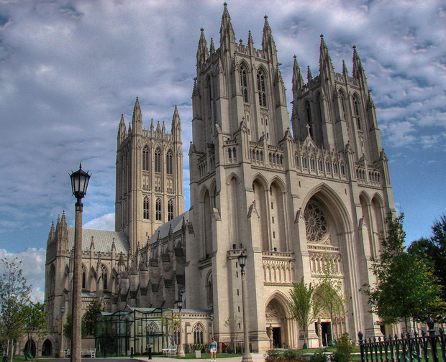
Tuesday Warm Up: Guess: How did the Church become the most powerful organization in Europe?
Wednesday: Estimate how many years it would take to build this cathedral….
Thursday: Match each of these words with its meaning.
Clergy Home for monks
Schism Female monk
Monastery Split in the Church
Investiture Member of the Church
Nun Non-Church selecting the Clergy
Friday Warm Up: What happens when more than one man claims to be the Pope? Guess.
Week 4
Monday Warm Up: What did knights do? Define a “Knight.”
Tuesday Warm Up: List five weapons with which knights would train.
Wednesday Warm Up: Draw a knight on his favorite horse.
Thursday Warm Up: What would be the best part about being a knight? The worst part?
Friday Warm Up: Make an Acrostic for the word KNIGHTS.

Week 3
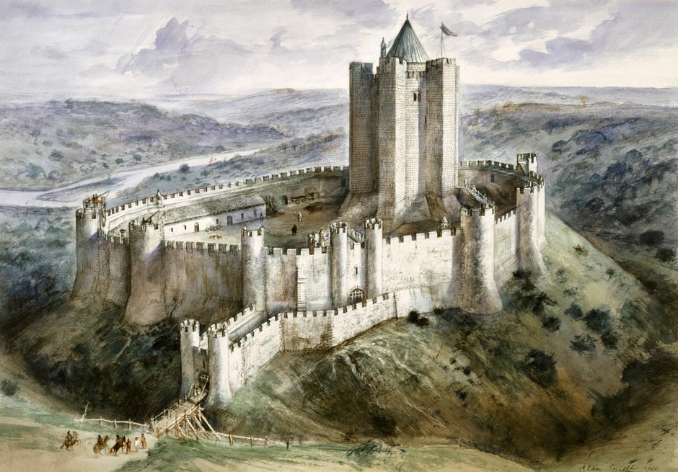
Monday Warm Up: Name three purposes of Castles.
Tuesday Warm Up: What is the most dangerous part of a castle? Safest?
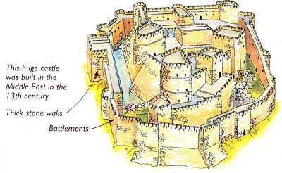
Wednesday Warm Up: This is the Castle you have to siege. How will you try to conquer it?
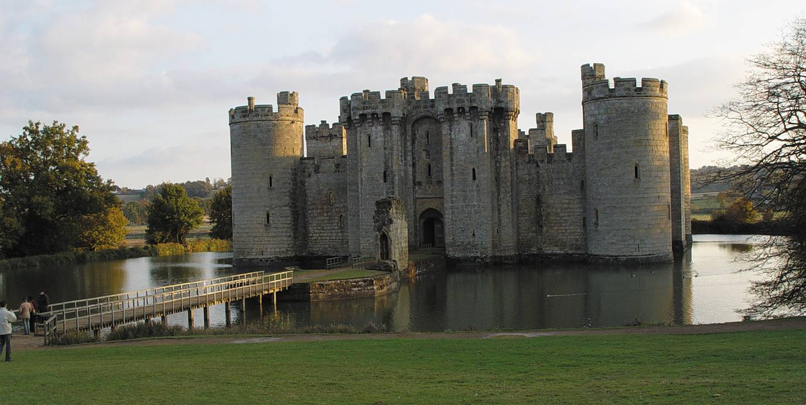
Thursday Warm Up: This is your Castle… how would you defend it?
Friday Warm Up:
Unscramble the following names:
SKIINGV RLMEEAACGNH TAMO
TEOMT YELIAB EBOREDRAG

Week 2
Monday Warm Up: Can you name three things that happened during the Middle Ages?

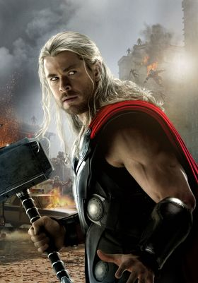
Tuesday Warm Up: Who is he? What does he control? Who originally worshipped him? And what does Hollywood get wrong?

Wednesday Warm Up: Many medieval figures are called “…the Great.” What do you think people need to do before they can be called that?
Thursday Warm Up: List three facts you know about Charlemagne.

Friday Warm Up:
Why were Christians in Europe so afraid of Muslims?

Week 1
Please pull out a piece of paper, write your Name, Date, and Period, and answer:
Monday Warm Up: What do you think we will learn in this class?

Tuesday Warm Up: What are the Middle Ages? What ended that started the M. Ages?
Wednesday Warm Up: Write down three questions you honestly have about the Middle Ages.
1-were they really as obsessed with chivalry as they were in medieval times?
2- What was the common greeting?
3- What China doing?
4-Did the different manors have slightly different ways of talking?
5-Were they any other lethal diseases in the middle ages?
6-How did they use the bathroom in armour?
7-did people choose to be knights or was it hereditary?
8- What myths did they believe in?
9-How many knights or guards were there at each castle?
10-Could swords go through knight armour?
11- Any sports?
12-How did they build infrastructure?
13- Who were the most famous female leaders and knights?
14-How many Viking tribes?
15-Did the knights have cannons?
16- What are the struggles of a knight in the middle ages
17-How long to build castle?
20-How did people organize the kingdoms when Rome fell?
21-Was it possible to change your social position in a negative way?
21-How did the Black Death start?
22-Were there different levels of knights?
23-Did knights get PTSD
24-Where did they get all the resources for castles?
25-Who had the greatest medieval influenecers?

Thursday Warm Up: What happened to Europe when Rome fell?
Friday Warm Up: Draw a picture for 4 of these words that demonstrate what the words mean.
Manor Chivalry Medieval
Feudalism Serf Ancient
Clergy Noble Rome

