WARM UPS for MYTHOLOGY
Week 9
5/18 Warm Up: If you had to make trading cards of any ten mythological figures, ancient or modern, which ones would you choose?
5/19 Warm Up:
Who would win in a fight?
Zeus vs. Superman Captain America vs. Achilles
Thor vs. Thor Fenrir vs. Cerberus Tezcatlipoca vs. Loki
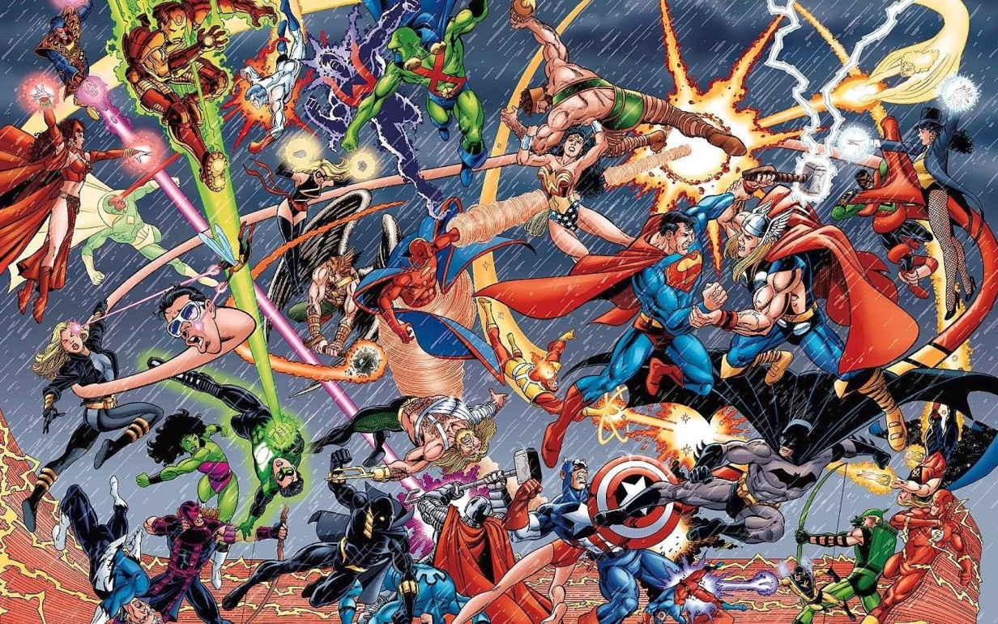
5/20 Warm Up: Define a HERO.
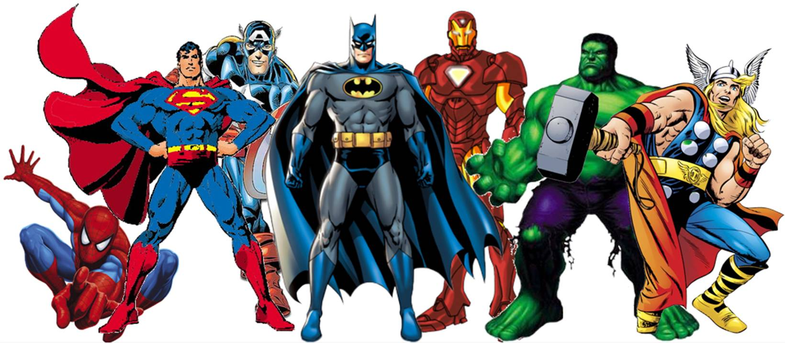
5/21 Warm Up: Define a VILLAIN.
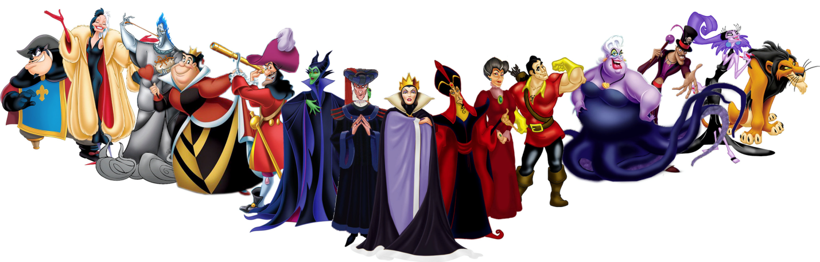

5/21 Warm Up: Pull out your Trading Cards. Be ready to play.

Week 8

5/11
Warm Up: What
is this symbol called?
What does it mean?

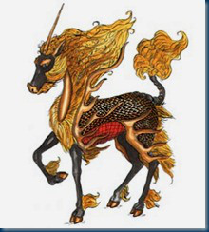
5/12 Warm Up: What on Earth is this thing and what are its powers?

5/13 Warm Up: True or False… the real story of Hua Mulan involved…
_Her fellow soldiers were shocked when they discovered Hua Mulan was a girl during the battle.
_She took her aged, weak father’s place as a soldier.
_She fell in love with the commander of the army.
_She fought against the Huns when China was at its weakest.
5/14 Warm Up: How many of these can you name?

5/15 Warm Up: What changes would you have made to your Action Figure if you had to change anything? What grade would you give your Action Figure as a project?

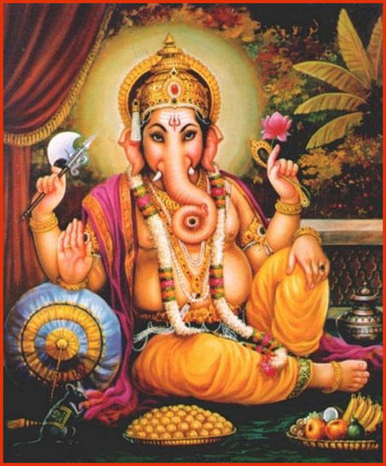
Week 7
5/4 Warm Up: Which part of the world is this god a part of the native mythology? How can you tell?

5/5 Warm Up:
Student A: “Hinduism is a religion that worships only one god, like Christianity or Judaism.”
Student B: “Hinduism is the best example of polytheism in the world!”
With which student do you agree and why?
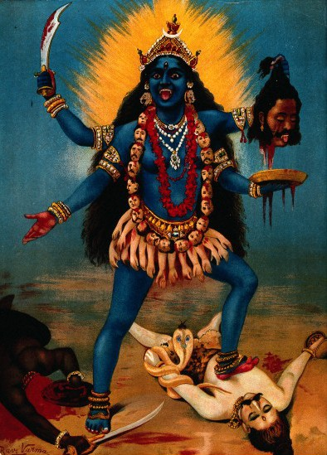
5/6 Warm Up: Which god in Hindu mythology is this? And what do you think has happened in this image?

5/7 Warm Up: Our class has a culminating activity. We are going to create an action figure/doll based on any mythology being from any culture. About which figure in any mythology will you be creating your action figure? Why?

Zeus (Aguilar), Tyr (Sanchez), Fenrir (cotton balls and pop sticks, sharpies, for Wilcox), Lakshmi (Rodgers), (Skulls, lace, and flowers for Guerra), (Paint, Lynn), Surt (Otis), Shiva (Whitaker), (baby snakes, Zaremba), Hod (Bendall),

5/8 Warm Up: Can you identify which of these Marvel adaptations is each of the Hindu pantheon?
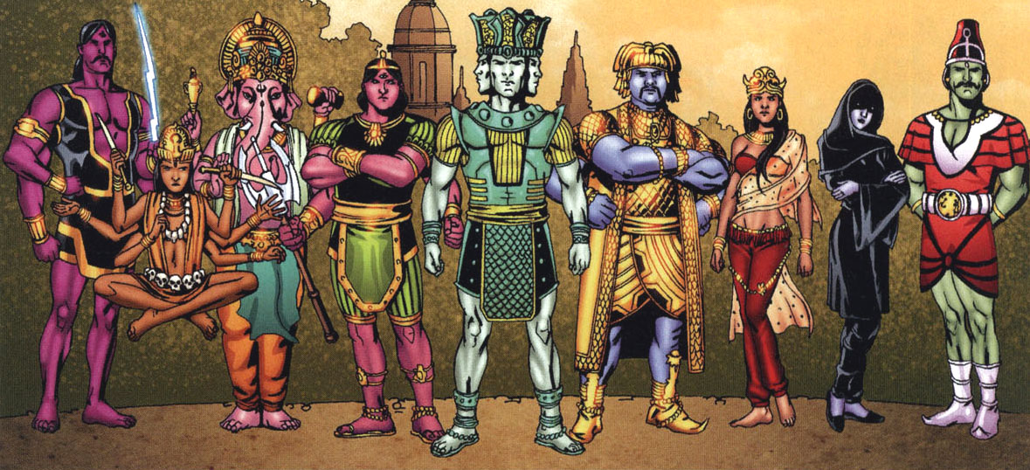

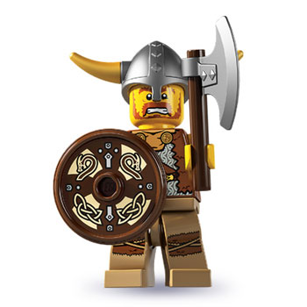
Week 6
4/27 Warm Up: Tell me what you know about these guys.

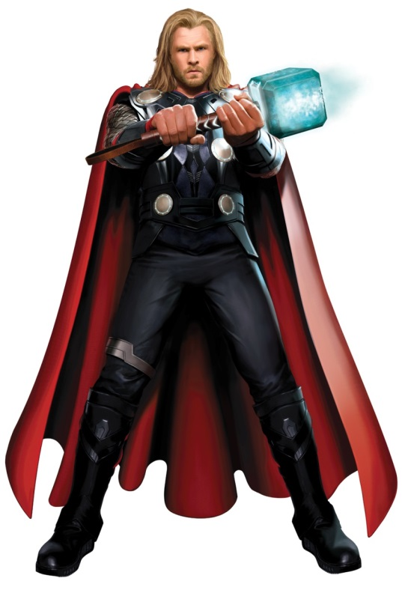
4/28 Warm Up:
- Who is he?
- What are his powers?
- How true to Norse Mythology is this representation in the movies?

Sanchez: Thor Rodgers: Freyja Lynn: Loki
Aguilar: Tyr Abenhaim: Hel Etkin: Odin
Bendall: Heimdall Laarej: Garm Whitaker: Jormungand
Wilcox: Helheim Conyers: Baldur Otis: Frey
Guerra: Idun Cunningham: Bragi Hopkins: Hod

4/29 Warm Up: Draw one of these figures…
Valkyrie Fenrir Yggdrasil
Garm Surtur
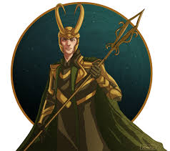
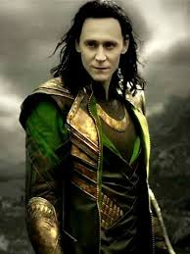
Loki in the movies and in the comics
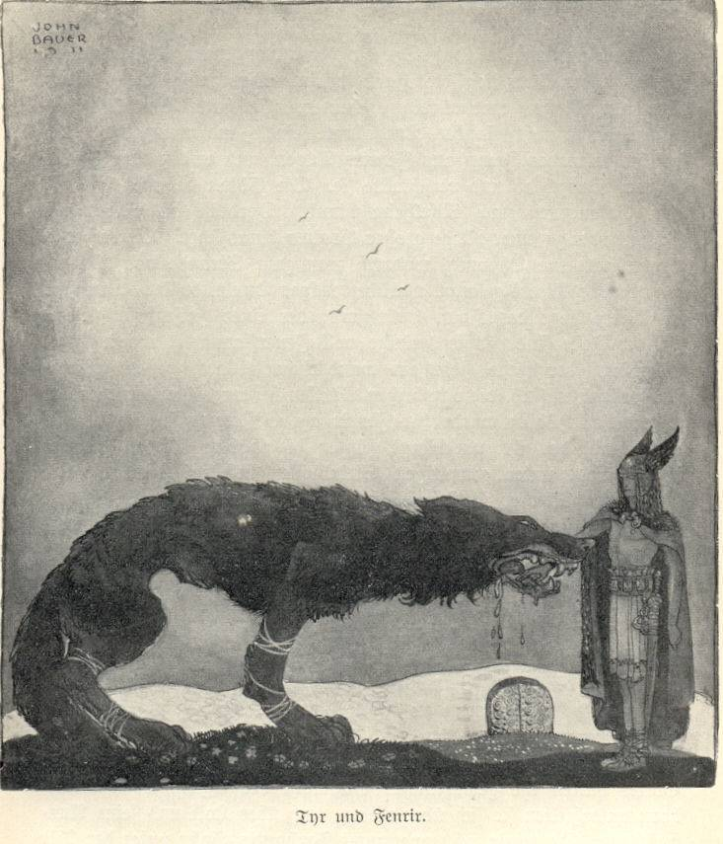
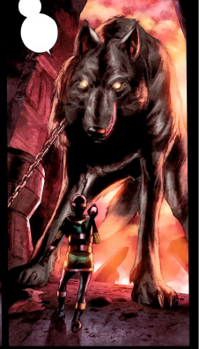

Garm and Fenrir

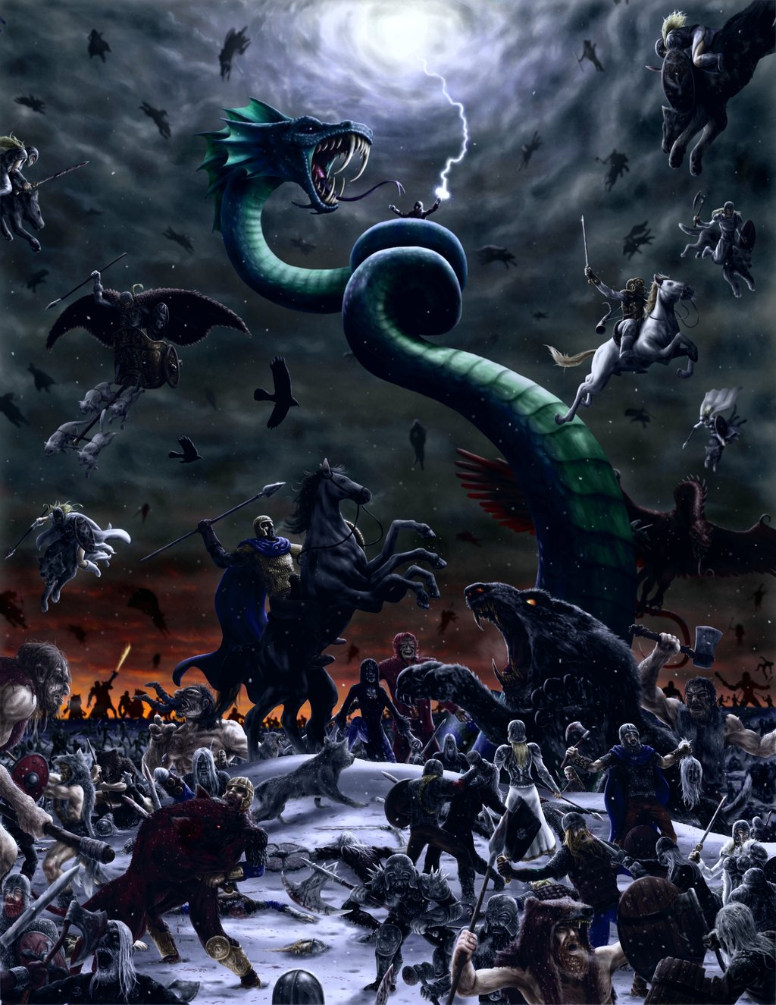
4/30 Warm Up: What does the final battle Ragnarok tell us about the Vikings?

5/1 Warm Up: In the final battle of Ragnarok, who fights against whom?
Thor Loki
Heimdall Fenrir
Tyr Surtur
Valhalla’s warriors Jormungand
Odin’s son Vioarr Garm
Freyr Helheim’s legions of dead
Week 5
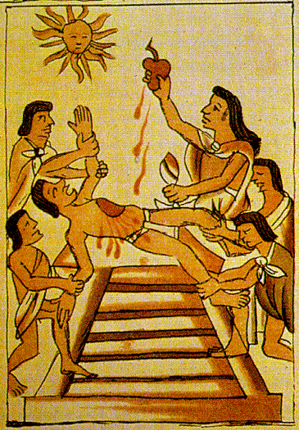
4/20 Warm Up: Which people are responsible for what is happening in the picture and for what reason are they doing it? Guess if you don’t know.

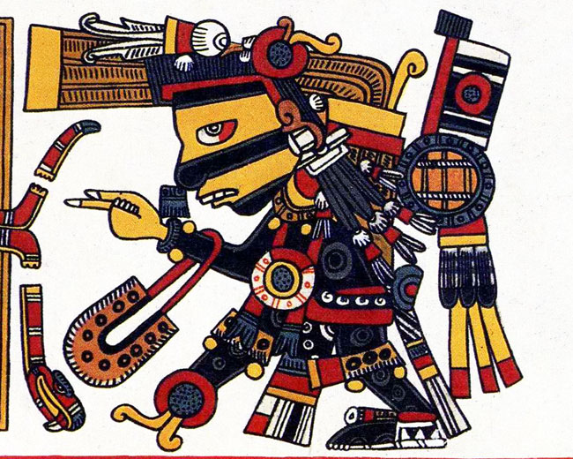
4/21 Warm Up: Based on the qualities you see on the Aztec god, which deity does this illustrate? Justify.
- Huitzilopochtli
- Tezcatlipocha
- Quetzalcoatl
- Ometeotl
4/22 Warm Up: Explain what is represented in the center of this flag. What does it have to do with the Aztecs?

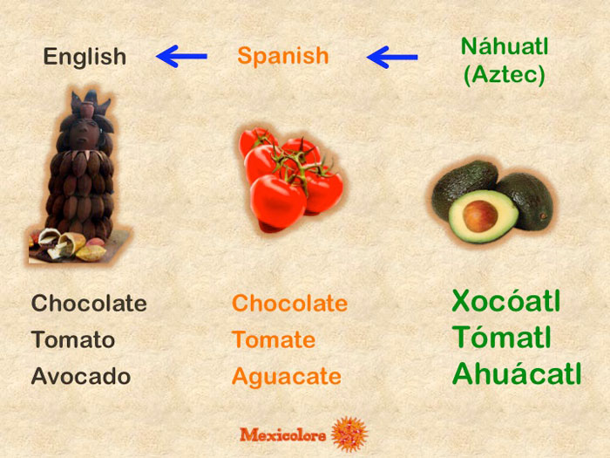

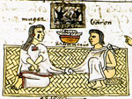
4/23 Warm Up: The Aztecs had a common saying,

“Noyollo iiztaia, moyollo iiztaia,” which meant, “My heart becomes white, your heart becomes white.”

It is what a newly married bride and groom would say to one another.

Guess why people in love would say this to one another. Consider what you know of Aztec culture.

4/24 Warm Up: Before the Quiz, see if you can unscramble these Aztec deities/things:
- CCTTEZIPLOAA =
- COUAAZLTTLEQ =
- LICHHUIZTOPILOT =
- CATLOL =
- MAAHCPIN =
Now identify the domain of each.

Week 4
8/17 Warm Up:
What is the oldest written example of mythology in the world? From which part of the world does it come, and how old do you think it is?

8/18 Warm Up:
“When the gods created Gilgamesh they gave him a perfect body. Shamash the glorious sun endowed him with beauty, Adad the god of the storm endowed him with courage, the great gods made his beauty perfect, surpassing all others, terrifying like a great wild bull. Two thirds they made him god and one third man.”

Based on the excerpt from the Epic of Gilgamesh above, what can you determine is something that Gilgamesh lacked? Justify your answer.
- An attractive face and body C. Incredible strength and stamina
- Humility and patience D. Bravery to face danger
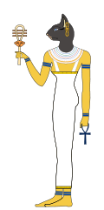
8/19 Warm Up:
Um… why does this Egyptian god have the head of a cat?
- All Egyptians had cat heads.
- All Egyptians worshipped cats.
- Egyptian mythology is so old, it merges human and animal features.
- The Egyptians weren’t polytheistic; this was a way of making fun of the “gods.”

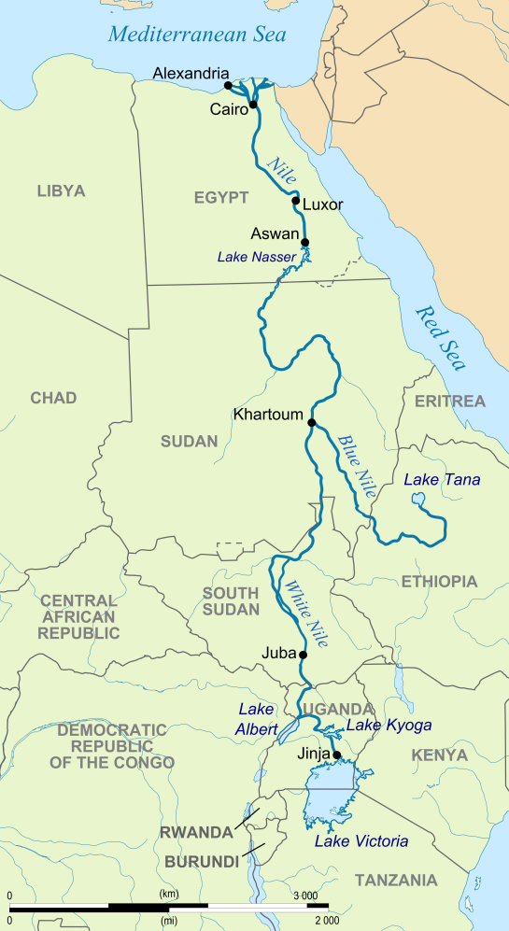

8/20 Warm Up: According to the map, is Cairo in Upper Egypt or Lower Egypt, hmm?
Justify your answer.
8/21 Warm Up:
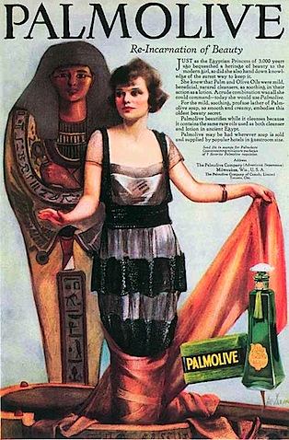
So why is this Soap advertisement showing a sarcophagus? Justify.
- The Ancient Egyptians were very obsessive with personal hygiene.
- Most soap is aged at least two thousand years before it is used.
- It is a scary advertisement, which frequently worked in selling hygiene products.
- There was a huge Egyptology craze in the 1920s after the discovery of King Tut’s tomb.

Week 3
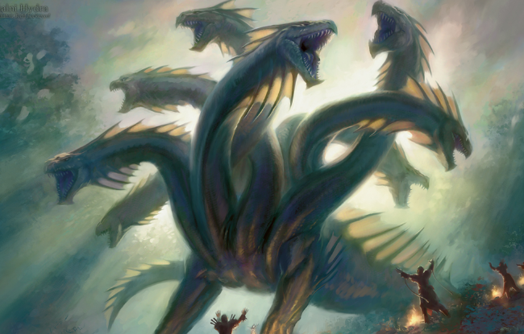
8/9 Warm Up: What kind of a Greek mythological creature is this? Guess at its powers.

8/10 Warm Up:
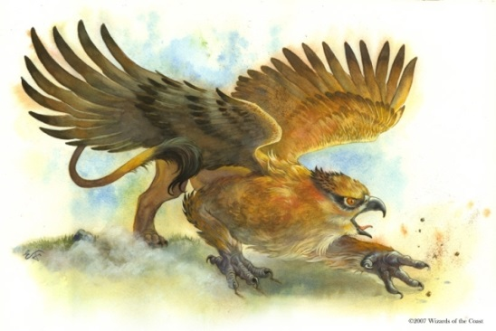
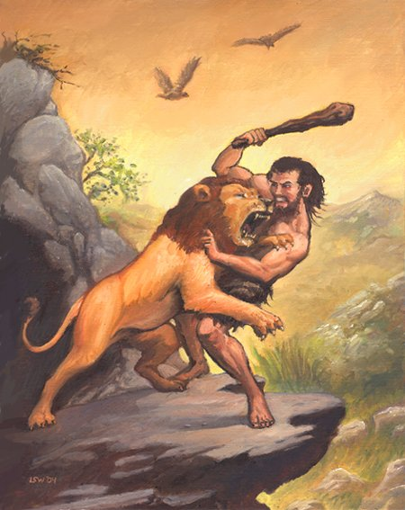
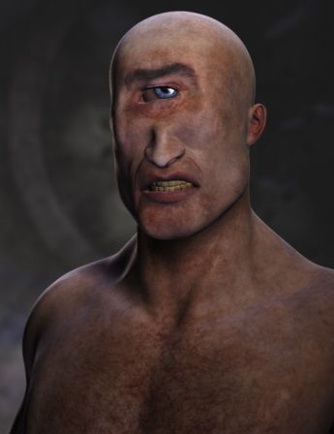
How does your monster compare/contrast with these three?

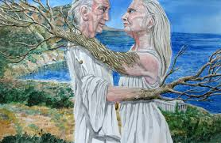
8/11 Warm Up: What is the lesson of the story of Baucis and Philemon? Justify.
- It’s best to be nice to strangers.
- Don’t boast you’re better than the gods.
- Some fights are impossible to win.
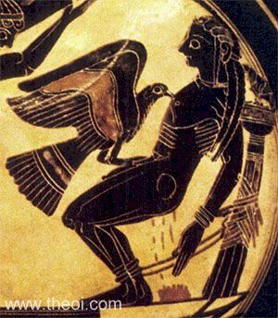
- Trees are alive; treat them with kindness.
8/12 Warm Up: The myth of Prometheus involved a vulture pecking out the immortal titan’s liver every day and letting it grow back. What is this an example of? Justify.
- Don’t betray family. C. Nature gets revenge.
- Don’t make Zeus mad. D. Vultures are evil.
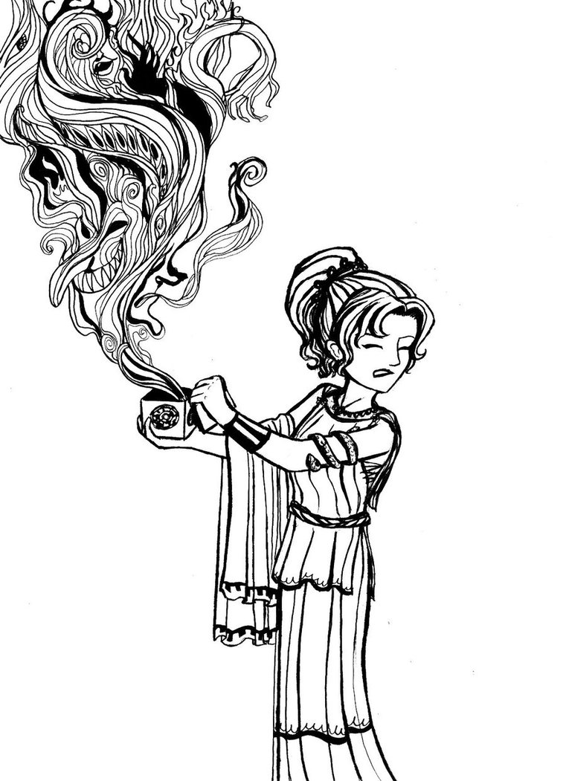
8/13 Warm Up: Which Greek myth character explains why there are evils in the world? Justify.
- King Midas
- Narcissus
- Pygmalion
- Pandora

Week 2
8/3 Warm Up: “The deeper I go into mythology, the more I find. I originally did five Percy Jackson books. I thought that would cover Greek mythology and I couldn't have been more wrong. It's ever-expanding.” With what does Rick Riordan’s quote agree? JUSTIFY your answer.
- There isn’t enough Greek mythology
- Mythology never ends
- Greek and Egyptian mythology are the same
- Ancient mythology is the same as modern religion

8/4 Warm Up: Can you match each with their Roman name?
Zeus Mercury
Hera Neptune
Apollo Jupiter
Poseidon Apollo
Hermes Juno

Demeter Mars
Athena Ceres
Aphrodite Diana
Ares Minerva
Artemis Venus

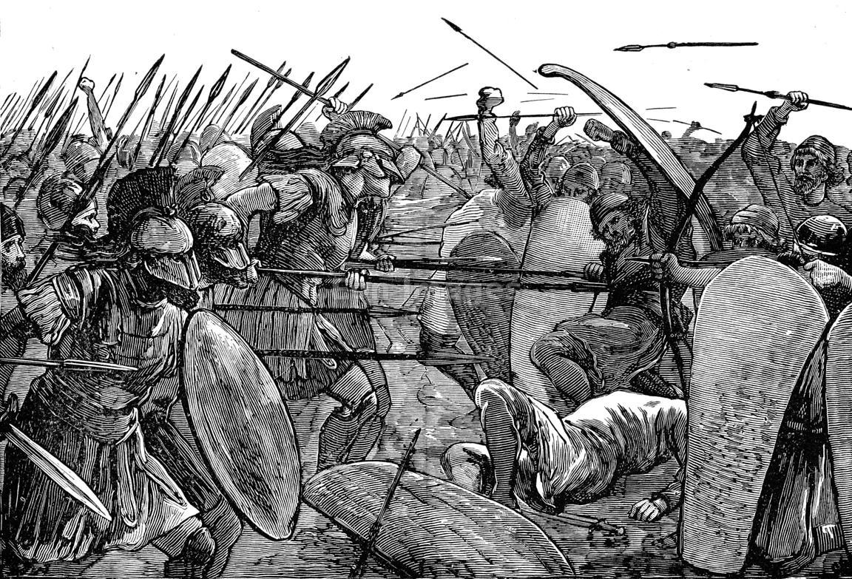
8/5 Warm Up: What real event do you think inspired the Trojan War described in Homer’s Iliad?
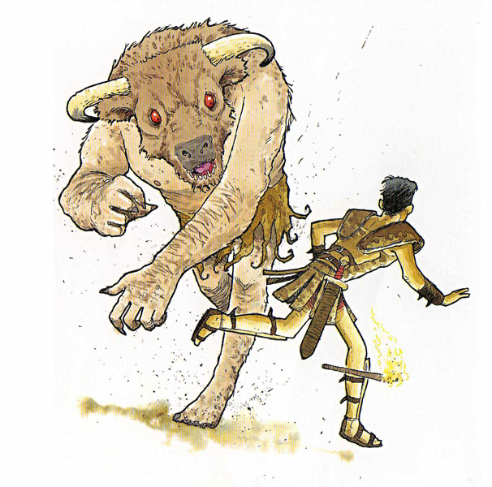
8/6 Warm Up: What can you tell about the ancient Greeks from the Theseus myth?

Week 1
7/27 Warm Up: What do you expect to learn in this class? (Name three things.)
7/28 Warm Up: “Superheroes fill a gap in the pop culture psyche, similar to the role of Greek mythology. There isn't really anything else that does the job in modern terms. For me, Batman is the one that can most clearly be taken seriously.” What is Christopher Nolan saying?
- Greek gods are stronger than superheroes.
- Batman could exist, but gods could not.
- People need superheroes as they used to believe Greek gods.
- Nobody believes in superheroes, just like no one needs mythology anymore.

7/29 Warm Up: Match these gods with their domains (powers).
Zeus Wine and parties
Hera Lightning and justice
Hermes War
Ares Marriage
Dionysus Speed, merchants, messengers

Athena Harvest, food, seasons
Hestia Weapons and Volcanos
Demeter Wisdom, crafts, and war
Hephaestus Beauty and love
Aphrodite Fireplace (hearth)

Warm Up for 7/30: The myths served many functions for the Greeks. Which of the following purposes did they not serve?
(A) Literature, functioning as entertainment and pure fantasy
(B) Science, explaining the mechanics of the physical world
(C) Prophecy, showing how the world will end
(D) Religion, explaining the role of gods and morality in everyday life
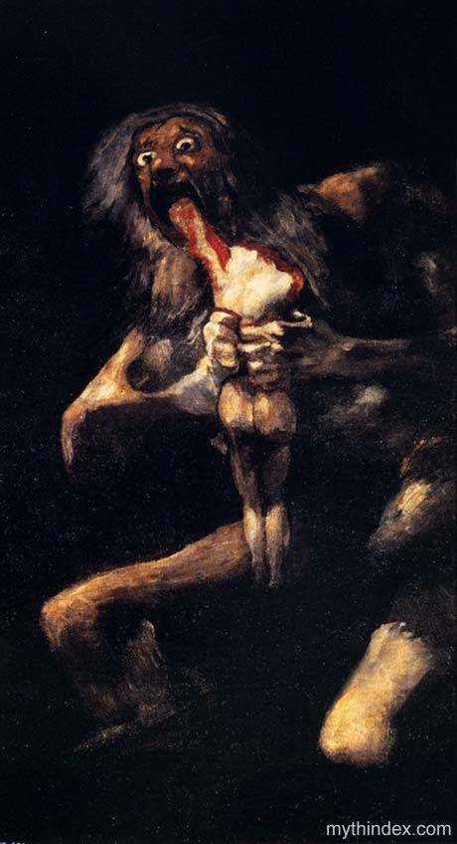
7/31 Warm Up: What does this portrayal of Greek mythology tell you about the Greeks? (It is the Spanish painter Goya’s Saturn Devouring His Children.) State why.
- Greeks believed in happy endings because their lives were pleasant.
- Greeks believed that families did not matter, because even the dads killed their kids.
- To Greeks, the greatest crime was eating too much, like Cronos/Saturn did.
D. In Greece, there was always a fight for power, as even the gods fought their family members.

